

Earned Value Management
System Description

September 2011

Version Control Table
Version | Date | Author | Changes
0.1 | 08/16/10 | WH | Original version delivered to KK for distribution
0.2 | 12/01/10 | WH | Updated version delivered to KK for distribution
0.3 | 01/11/11 | WH | Updated version delivered to SB for distribution
0.4 | 01/18/11 | WH | Updated version delivered to SB for EVM Council Meeting
0.5 | 02/11/11 | WH | Updated version delivered to SB for distribution
0.6 | 07/25/11 | WH | Updated version delivered to SB for distribution
0.7 | 08/31/11 | WH | Updated version delivered to MF for distribution
0.8 | 9/16/11 | VC | Administrative update: Removed “**” from Appendix D – EVM Standard Terms and Definitions

Table of Contents
1 Introduction 6
1.1 Document Organization 6
1.2 Overview of Earned Value Management System 6
1.3 FAA EVM Performance Measurement Baseline Management Process 7
2 FAA Earned Value Management PMB Environment 8
2.1 Baseline Components 8
2.1.1 Estimated Lifecycle Cost 8
2.1.2 EVM Total Allocated Budget 9
2.1.3 Acquisition Program Baseline 9
2.1.4 Earned Value Management Total Allocated Budget Relationships 10
2.2 EVM Total Allocated Budget 10
2.2.1 EVM Total Allocated Budget Attributes 11
2.2.2 Program Reserves 13
3 FAA Program Organization 13
3.1 Investment Analysis (Planning) Phase 13
3.1.1 Implementation Strategy and Planning Document 14
3.1.2 Program Work Breakdown Structure 15
3.1.3 Contract Work Breakdown Structure 15
3.1.4 Responsibility Assignment Matrix 15
3.1.5 Program IT Dashboard Milestone Table 16
3.2 Post FID Activities 17
3.2.1 Update EVM Planning Documents 17
4 FAA Program Planning 17
4.1 Establish Performance Measurement Baseline 17
4.1.1 Control Account Budget Components 17
Work Package 17
Planning Package 18
Summary-Level Planning Package 18
Elements of Cost 18
4.2 Establish Program Performance Baseline 18
4.2.1 Development of Management Reserve and Schedule Reserve 18
Management Cost Reserve (MCR) 19
Management Schedule Reserve (MSR) 21
4.2.2 Program Detailed Schedule 22
4.2.3 Program Detailed Budgets 22
4.2.4 Work Authorization Document 22
4.3 Earned Value Methods 22
4.4 PMB Change Control 22
5 FAA Program Analysis and Management Reporting 22
5.1 Program Status Reporting and Variance Analysis 23
5.1.1 Status Program Schedule 24
5.1.2 Program Schedule Changes 26
5.1.3 Earned Value Calculations 26
5.1.4 Estimated Costs for Earned Value Work Accomplished 26
5.1.5 Summarized EVM Performance Measurement Data 26
Control Account Estimate at Completion 28
5.1.6 Generate Earned Value Reports 28
Internal Review by Program Manager 28
5.2 EVM Governance 29
5.2.1 Program Earned Value Management System Assessment Process 29
5.2.2 Post FID EVM Assessment 29
5.2.3 Contractor System Acceptance 29
5.2.4 Program Integrated Baseline Review (IBR) 30
5.2.5 Contractor Level IBR 30
5.3 Program Surveillance 31
6 PMB Revisions and Data Maintenance 31
6.1 EVM PMB Change Control 31
6.1.1 Types of Baseline Changes 32
6.1.2 The Change Control Process 33
6.2 Baseline Reconciliation 35
7 Earned Value Management Roles and Responsibilities 37
7.1 Program Key Roles 37
7.1.1 Program Manager 37
7.1.2 Control Account Manager 38
7.1.3 Business Manager 39
7.1.4 Investment Decision Authority 39
Appendix A: GAO Seven Components of an Effective EVM Policy 40
Appendix B: RAM Template 42
Appendix C: Program Planning Template 43
Appendix D: EVM Standard Terms and Definitions 44

Introduction
This document describes the Federal Aviation Administration’s (FAA) approach to Earned Value Management (EVM) and provides guidance for the program implementation of an FAA Earned Value Management System (EVMS). The System Description also refers to the tools, techniques and processes required to implement and maintain an American National Standards Institute (ANSI)/Electronics Industry Alliance (EIA)-748 compliant EVMS. In order to meet the agency’s EVM requirements, each program is required to follow the guidance established in this document. Any deviations from the outlined procedure must be approved by the EVM Focal Point located in the JRC Investment Process Management Division, under the Deputy Assistant Administrator for Acquisition and Business/Chief Acquisition Officer.

Document Organization
This document is organized around defining the FAA EVM Performance Measurement Baseline (PMB) Environment, FAA Program Organization, FAA Program Planning, FAA Program Analysis and Management Reporting, FAA PMB Revisions and Data Maintenance, and FAA EVM Roles and Responsibilities. This aligns with the logical flow of the program lifecycle, beginning with program organization, program planning, program execution, and managing and controlling the program plan.

Overview of Earned Value Management System
The primary purpose of the FAA’s EVMS is to provide timely, valid, auditable, actionable, and reliable program cost, schedule and technical performance information to both internal management and external stakeholders such as: the Department of Transportation (DOT), the Office of Management and Budget (OMB), Government Accountability Office (GAO), Inspector General (IG), and Congress. Additionally, the EVMS provides “early warning” metrics and trends for cost, schedule and technical performance. Assessment of FAA’s EVM Policies and Procedure Compliance with GAO EVM Best Practices is provided in Appendix A.
The FAA EVM implementation is correlated with the Acquisition Management System (AMS) standard program milestones. The AMS standard program milestones represent key technical milestones, with most including quality and system assurance oversight. The completion criteria for most of these milestones represent quality technical accomplishments. The key characteristics of the FAA approach for EVM include:
- Integration of technical (AMS standard program milestones), cost and schedule measurements as the basis for planning, budgeting, authorizing work, and measuring performance;
- Earned value data that represents the majority of work accomplished toward achieving AMS standard program milestones;
- Reliable data that details work progress as it relates to schedule status;
- Earned value cost, schedule and technical performance data that is readily available and can provide early warning metrics and trends which enable corrective action or risk mitigation;
- Data that provides management with schedule and cost reserves to enable risk mitigation and to accommodate unforeseen schedule and cost problems;
- EVM Performance Measurement Baseline (PMB) management controls that ensure cost, schedule and technical performance reflects the most current program baseline approved by the Joint Resource Council (JRC); and
- Common standard cost, schedule and technical metrics that can be used for portfolio management by FAA management.

FAA EVM Performance Measurement Baseline Management Process
The EVM PMB is partially established during the Planning phase (Investment Analysis). The EVM PMB is then baselined by the program manager during the Solution Implementation phase of the FAA AMS Lifecycle Management Process.
The following sections describe the Planning and Solution Implementation phases and their relationship with the EVM PMB.
Investment Analysis Phase:
After the Initial Investment Decision (IID), the program establishes an acquisition plan for the investment. The acquisition plan consists of several program planning documents that are prepared, reviewed, and approved by FAA functional staff prior to obtaining the Final Investment Decision (FID) by the JRC. The program planning documents include EVM plans and artifacts that are addressed in detail later in this document. The FAA EVM Focal Point Office can approve waivers and deviations from the EVM PMB requirements during the Planning phase.
During the Investment Analysis Phase, the program also develops a Capital Planning and Investment Control (CPIC) Plan of Actions and Milestones (POAM) for implementing and establishing the program PMB. The POAM is used to monitor the program’s progress and create documentation required for the IT Dashboard that will be reported to OMB after the final investment decision (FID).
Post - Final Investment Decision / Solution Implementation Phase:
The FID completes the Planning phase and also marks the beginning of the Solution Implementation phase. During this phase, the programs are responsible for implementing EVM in a manner that is consistent with the EVM plans and artifacts previously approved and with the FAA EVM System Description.
The program is evaluated by the Chief Information Officer (AIO) Earned Value Management Office to verify that the implemented EVMS is consistent with the ANSI/EIA 748 EVM Standard. This step is required by AMS and uses the FAA Program Control EVM Assessment Review Criteria.
The FAA System Description defines the EVM requirements. It also identifies FAA EVM standards that the program uses and identifies areas that the programs develop for their unique approach. The program implements EVM and uses EVM data to report program schedule and cost performance for internal reports such as Simplified Program Information Reporting and Evaluation (SPIRE) and EVM Focal Point Office EVM reports. It also uses this data to develop external stakeholder reports for DOT, OMB and GAO.
This document provides the requirements for documenting and managing the PMB, and defines the process for requesting and receiving approval for discontinuing the use of EVM.

FAA Earned Value Management PMB Environment
The EVM PMB cost, schedule and technical baselines are derived from the FID approved business case documentation for the Business Case Analysis Report (BCAR) and the Acquisition Program Baseline (APB). Figure 1 illustrates how the PMB and Management Reserve (MR) relate to the FID documentation, BCAR, and APB.
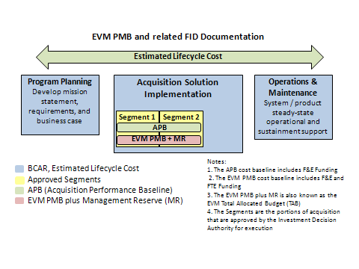

Figure 1: EVM PMB and Related FID Documentation

Baseline Components
The EVM PMB is the approved acquisition segment(s) portion of the estimated lifecycle cost. The scope and schedule baselines for the APB and the EVM PMB are identical. The APB cost baseline includes Facilities and Equipment (F&E) funding while the PMB cost baseline includes funding for F&E and Government full time equivalent (FTE).

Estimated Lifecycle Cost
The Estimated Lifecycle Cost is the total cost to the FAA for acquiring, operating, maintaining, supporting and disposal of systems or services over their useful life. The BCAR identifies the baselined segments approved by the JRC. The BCAR identifies the funding for the approved baselined segments. The funding types and relationship to program phases are shown in Figure 2.
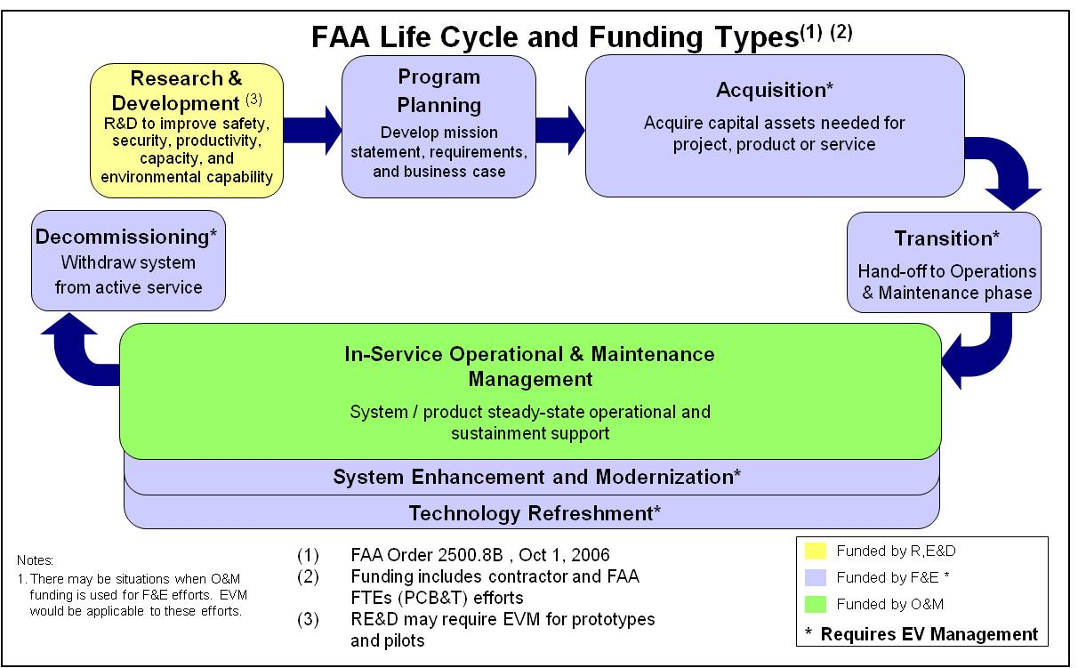
Figure 2: FAA Life Cycle and Funding Types

EVM Total Allocated Budget
The EVM Total Allocated Budget (TAB) is comprised of the PMB and MR. The TAB is also the combined value of the APB cost baseline and the value of the FTEs as documented in the BCAR.
The JRC usually approves the Solution Implementation phase in segments or phases. The BCAR identifies the cost for the baseline segments by F&E, Government FTE, Operational and Maintenance (O&M), etc. As segments are approved by the JRC, cost, schedule and technical attributes can be incorporated into an existing APB or be measured as a standalone APB. If there is a separate APB for each segment, there will also be a separate PMB for each segment.

Acquisition Program Baseline
The APB establishes the performance to be achieved by an investment program, as well as the cost and schedule boundaries within which the program is authorized to proceed. The acquisition program baseline is a formal document approved by the JRC at the FID. It is a contract between the JRC and the program manager of the service organization that the acquisition has been assigned to.
The APB domain is Solution Implementation and does not include the costs incurred prior to the FID, nor does it contain O&M costs associated with the In-Service Management phase.
The APB and the PMB have identical scope attributes. Although the PMB schedule baseline is based on the APB schedule baseline, the PMB schedule baseline may include schedule challenges (management schedule reserve). The PMB cost baseline includes the APB F&E cost plus the Government FTE’s as documented in the BCAR. The PMB cost baseline may include cost challenges or cost management reserve.

Earned Value Management Total Allocated Budget Relationships
The EVM TAB is the total planned cost consistent with the program segments, which is approved by the JRC. This includes Solution Implementation scope for the approved segments as documented in the BCAR and the APB. There may be instances where acquisition costs are included in the Planning or O&M phases. The EVM TAB includes the PMB and the cost MR for both F&E and Government FTE costs.
The relationship between the EVM TAB, BCAR, and the APB is illustrated in Figure 3 below:
Baseline | Planning | Solution Implementation |  |  |  |  | O&M
Baseline | Planning | Acquisition Costs |  |  | Schedule | Scope | O&M
Baseline | Planning | FTE | F&E | MR | Schedule | Scope | O&M
Estimated Lifecycle Cost | X | X | X | X | Described in the BCAR and ISPD. | Consistent with the Requirements Document. | X
APB  (One or more segments) |  |  | X | X | APB Program Milestones | Consistent with the Requirements Document. Includes system / product quantities.
EVM Total Allocated Budget (TAB) |  | X | X | X | APB Program Milestones | Consistent with the Requirements Document. Includes system / product quantities.
Figure 3: EVM TAB Relationships

EVM Total Allocated Budget
The EVM TAB is segregated into the PMB and the program manager’s MR. The PMB is further segregated into Work Breakdown Structure (WBS) elements for control accounts (CA), summary level planning packages (SLPP), work packages (WP), and planning packages (PP), as illustrated in Figure 4.
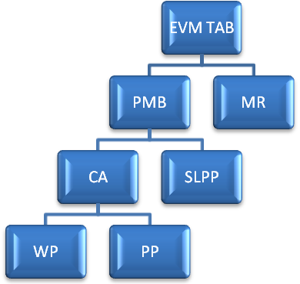
Legend
TAB – Total Allocated Budget
PMB – Performance Measurement Baseline
MR – Management Reserve
CA – Control Account
SLPP – Summary Level Planning Package
WP – Work Package
PP – Planning Package
Figure 4: EVM TAB Breakdown
- Control Account (CA): a management control point where scope, budget, actual cost, and schedule are integrated and compared to earned value to report EVM schedule and cost performance. A control account is comprised of WPs and PPs.
- Work Package (WP): a subdivision of a CA, representing tasks and activities, authorized to expend funds by the program manager. A WP represents work which is detail-planned with budget, schedule activities / milestones, and EVM methods.
- Planning Package (PP): a holding account (within a control account) for future effort that has not been detail-planned at the WP level. PPs are used for future effort that is not well-defined and will be detail-planned prior to expending funds. The PP budget is time-phased in accordance with known schedule requirements for resource and funds planning.
- Summary Level Planning Package (SLPP): a WBS holding account for future budget that is associated with JRC approved scope; but not yet allocated to a CA. Typically used for future effort that has not received Appropriated funding as defined in the FAA Capital Investment Plan (CIP).
- Management Reserve (MR): a cost reserve held at the program level and controlled by the program manager for risk mitigation and for unanticipated tasks consistent with the JRC approved Program Segments.

EVM Total Allocated Budget Attributes
Performance Management Baseline
The PMB represents the time-phased budget (planned cost) that is established by the program manager and is used to report program EVM schedule and cost performance to FAA management and external stakeholders. The PMB is segregated by CA and SLPP as documented in the Responsibility Assignment Matrix (RAM). The PMB is subdivided into milestones as reported in the IT Dashboard Cost/Schedule Table.
- Cost Definition of the PMB: The PMB costs are the costs allocated to specific scope for a program consistent with the APB scope. The PMB consists of the time-phased costs at the WP, PP, and SLPP levels. The time-phasing of the budget is consistent with the program schedule and the Federal IT Dashboard Cost and Schedule Table milestones.
- Schedule Definition of the PMB: The program schedule related to the PMB is consistent with the Federal IT Dashboard Cost and Schedule Table milestone dates. The PMB includes the efforts and procurements to achieve milestones. The EVM PMB schedule baseline is defined by the APB Schedule Milestones.
- Technical Scope Definition of the PMB: The PMB technical scope includes the products, program milestones, and support included in the Program WBS used for the FID.
- Program WBS: The Program WBS is a subset of the FAA Standard WBS that represents the scope for the JRC approved Program Segments. The Program WBS is extended to CAs and SLPPs.
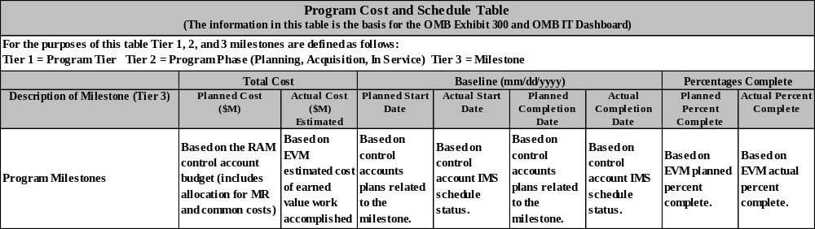
- IT Dashboard Cost/Schedule Table: The Program IT Dashboard Cost/Schedule Table is used to identify the program milestones that provide a measure of technical progress. The milestones are usually consistent with the Level One and Level Two AMS standard program milestones. This table is used to report program technical, schedule, and cost status to FAA management and external stakeholders. The acquisition milestone cost or budget values reported in this table are consistent with the TAB. EVM data is used for this table as illustrated in Figure 5:

Figure 5: Program Cost and Schedule Table
- Acquisition Program Baseline is part of the investment program document package that is approved by the JRC at the FID. The APB domain is Solution Implementation and does not include baseline costs incurred prior to the FID, nor does it contain as a baseline, the operations costs associated with In-Service Management. The APB consists of three interdependent acquisition baselines: schedule, cost, and performance.
- Acquisition Schedule Baseline consists of AMS Solution Implementation Level One, Two, and Three milestones selected from the AMS Standard Milestone List. The schedule duration is measured in months and is the period from the FID to the commissioning of the last system or equivalent milestone. In cases where the AMS standard milestones do not apply, the program office should work with Finance Baseline Management to develop a set of tailored measurable milestones to be used in the acquisition schedule baseline.
- Acquisition Cost Baseline includes costs for the prime contract, testing, deployment, site preparation, installation, and both headquarters and field support contracts. The cost baseline does not include government personnel benefits, compensation, and travel (PBC&T).
- Acquisition Performance Baseline contains the requirements in the Program Requirements document designated for control by the JRC. These consist of technical performance parameters and their associated values that are essential for achieving the desired operational effectiveness. The performance baseline also includes the quantity of systems being acquired.
- OMB Exhibit 300 Program Report is used to document and report the program business case and current program technical, schedule, and cost performance and is used to request annual funding.
- OMB IT Dashboard is a subset of the OMB Exhibit 300 program report. The IT Dashboard is updated to report program performance. The OMB IT Dashboard report includes the IT Dashboard Cost/Schedule Table for which EVM data is used to report cost and schedule status of technical milestones.

Program Reserves
Both cost and schedule management reserves are buffers held to ensure there are sufficient resources to address issues and to mitigate risks that arise during execution. The cost reserve is called the Management Cost Reserve (MCR) and the schedule reserve is called Management Schedule Reserve (MSR).
Management Cost Reserve: A portion of the program budget set aside for unforeseen risks and events that fall within program scope requirements. The program manager will establish management cost reserve after they consider all identified risks. Where possible, quantitative analyses of high impact and/or high probability risks will be performed to better understand the potential time and financial impacts to the program if the risks do occur. This process is fully documented in Section 4.2 of the System Description.
Schedule Reserve: The management schedule reserve is the time period that is withheld for management of schedule risks and unforeseen circumstances. Management Schedule Reserve (MSR) is managed at the program level and differs from float/slack in that it is managed at the program-level and not the schedule/task level. The program manager will establish MSR after he or she assesses program risks. Where possible, quantitative analyses of high impact and/or high probability risks will be performed to better understand the potential schedule impacts to the program if the risks do occur.

FAA Program Organization

Investment Analysis (Planning) Phase
The ANSI/EIA 748 EVM Standard uses the program management category “Organizing” to describe the planning activities for the WBS, program level schedule for key events, RAM, and program control procedures. The initial organizing activities occur during the Investment Analysis phase. There are four key EVM documents required during this phase: 1) Implementation Strategy and Planning Document (ISPD) --sections 3.2 Program Control and 2.8 Contract Management, 2) Program WBS, 3) RAM, and 4) the IT Dashboard cost/schedule milestone table.
Figure 6 identifies the high-level process the program will go through as it completes the Investment Analysis phase. Waivers from the Investment Analysis phase, also known as pre-FID, must be approved by the EVM Focal Point Office. A detailed explanation of each document as well as guidance for developing each document is provided in Section 3.1.1.

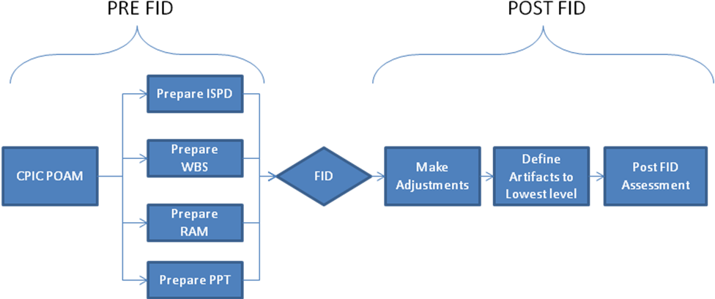
Figure 6: Investment Analysis Phase

Implementation Strategy and Planning Document
There are two sections of the ISPD related to EVM, sections 3.2 Program Control and 2.8 Contract Management that the FAA EVM Focal Point Office reviews and approves prior to FID. The EVM requirements for these sections are:
Section 3.2 Program Control
The program should state that the EVMS for program and contractor implementation will be consistent with the FAA AMS policies and guides. Deviations or waiver requests should be included in this section.
Section 2.8 Contract Management
This section should include a plan for contracting for EVM. The program should state the contract deliverables and Contract Data Requirements List (CDRL) that will be required to support EVM. The standard EVM CDRLs can be found on FAST at <FAA AMS Contract Clauses & Contract Writing>. This section should describe the statement of work (SOW) requirements for reporting program EVM performance data for program management reviews and other management reports. Programs are encouraged to define contractor EVM reports that can be used by program management during regular contract performance reviews.
Programs should require contractors to provide schedule status reports that include APB schedule milestones and IT Dashboard milestones. The programs should include a contract WBS that maps to the Program WBS.
This section should also include the plan for: the certification of contractor’s EVM, Integrated Baseline Reviews (IBR), and EVM surveillance consistent with AMS EVM policy.
The template for the ISPD can be found at Appendix B: Acquisition Planning and Control Documents

Program Work Breakdown Structure
The Program Work Breakdown structure (WBS) is the framework used to define each element of the program that will be monitored and tracked by program management in an effort to monitor the entire program’s technical progress. The Program WBS also includes the WBS elements required to support FAA internal and external stakeholder program performance reporting. The Program WBS clearly identifies the CAs and SLPPs that are required to complete the RAM (the RAM is described in this document). Directions and instruction for the WBS can be found at FAA Work Breakdown Structure.
The Program should organize the work using the FAA standard lifecycle WBS that follows the AMS lifecycle. The Program WBS is extended to CAs and SLPPs. CAs cannot be allocated to more than one higher level WBS element and one milestone.
CAs and SLPPs will be mapped to the Program IT Dashboard Cost/Schedule Table milestones. CAs and SLPPs cannot be allocated to more than one milestone.

Contract Work Breakdown Structure
The contract work breakdown structure (CWBS) is established and used by the prime contractor to report contract schedule and cost performance. The CWBS is structured to support IT Dashboard milestone performance reporting and is included in the screening information request (SIR). The program manager ensures the CWBS is consistent and compatible with the program WBS to facilitate incorporation of contractor performance information into program performance reports.
The CWBS should not specify an excessive number of lower level elements. The contractor should establish lower level WBS elements based on the contractors work plan. When determining the level for reporting, the program manager should extend the CWBS only to the level that allows visibility into those high-cost, high-risk, or other specific areas critical to the success of the program.
The statement of work (SOW) requires the contractor to extend the CWBS to meaningful management or product-oriented lower levels that reflect the way it does business, and to prepare and deliver a CWBS Index and Dictionary.

Responsibility Assignment Matrix
The Responsibility Assignment Matrix (RAM) integrates the WBS with the Organization Breakdown Structure (OBS) and provides a framework for organizing, planning, budgeting, measurement, monitoring, and reporting of program performance.
The OBS is the list of organizations responsible for performing and accomplishing program effort. The OBS includes organizations responsible for accomplishing measurable and discrete effort. The OBS does not include staff augmentation effort, such as program management and sustaining engineering support. The OBS is integrated into the FAA RAM. A RAM is a tabular or graphical matrix of the WBS and the responsible organizations that facilitate the assignment of CAs and a responsible control account manager (CAM). The primary objective of the RAM is to ensure that each CA is assigned to the organization directly responsible for managing the work.
A RAM includes the following items:
- CA identifier;
- OBS identifier;
- CAM (control account manager) name;
- CA or SLPP cost; and
- CA or SLPP period of performance.
The RAM maps the CA to the IT Dashboard milestones. The FAA standard RAM is illustrated in Figure 7.

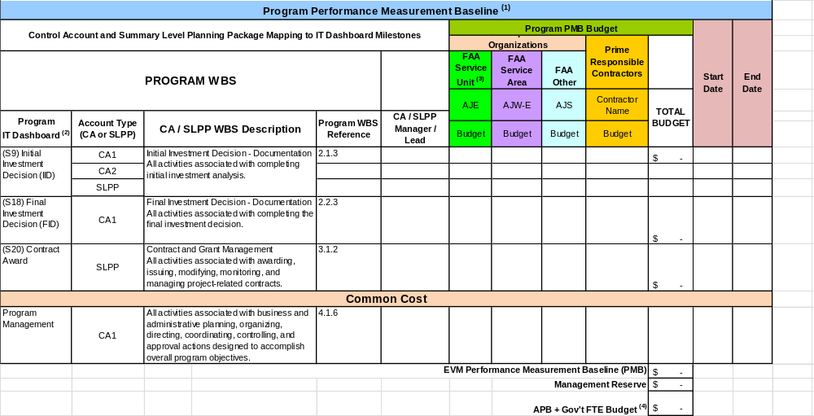
Figure 7: FAA RAM

Program IT Dashboard Milestone Table
The program develops the IT Dashboard Milestone Table using the PPT. The PPT is owned by the Finance Office. Guidance for developing the PPT can be obtained from the AIO Value Management Office.
EVM performance data is used to report the milestones for the OMB Exhibit 300 Cost and Schedule Milestone Table and the OMB IT Dashboard.
Note: See Appendix C for an example of the PPT

Post FID Activities
After the final investment decision, decisions that may impact the pre-FID EVM documentation will be updated to reflect the JRC approved program segment baseline.

Update EVM Planning Documents
Planning documents created during the pre-FID phase are revised to incorporate any corrections and detailed planning information that was not included in the pre-FID process. Documents that may have to be updated include:
- ISPD: update sections 3.2 - Program Control and 2.8 - Contract Management as required to reflect the plan approved by the JRC;
- WBS: The WBS needs to be extended into Control Accounts (CA) or Planning Packages (PP) for the effort funded and will be performed in the near term. Future effort and funding not appropriated may be planned as summary level planning packages (SLPP);
- IT Dashboard Milestones: Update as required to be consistent with the APB, cost baseline, and schedule baseline approved by the JRC;
- OBS: Update to include all organizations, FAA and contractors, responsible to accomplish the program effort; and
- RAM: Updates are based on updates to the CAs, SLPPs, and IT Dashboard milestones.

FAA Program Planning

Establish Performance Measurement Baseline
Once the EVM planning documents are updated, the Control Account Plans (CAP) and SLPPs are expanded and reserves are established for both cost and schedule.

Control Account Budget Components
CAs contain two key components of the program budget; the WP and the PP. Elements of Cost (EOC) are the building blocks for developing the budget. The following sections describe the components that make up the budgets developed during this process.

Work Package
A WP is a subdivision of a CA. It is a detailed plan of deliverables, milestones, and activities used in planning, controlling, and measuring program performance. It describes the work to be performed and serves as a vehicle for monitoring and reporting progress and accomplishing work. All WP and PP budgets must be added to the CA budget. Work Package characteristics include:
- Clear distinction from all other WPs;
- Scheduled start and completion dates;
- Development at the level at which work is performed and earned value is claimed;
- Assignment of budget or value (F&E and FTE labor dollars or measurable units); and
- Earned value methods.

Planning Package
A PP is an aggregate of future tasks and budgets within a control account that will eventually be detail planned and segregated into WPs. It represents far-term efforts that cannot be defined in detail at the start of the CA. PPs are similar to WPs in that they include scope, schedule and budget.
The work in a PP must be converted into WPs before that work begins. The CAM manages the conversion of a PP to WPs.

Summary-Level Planning Package
There are times when authorized work cannot be planned to the CA level. It is common for programs to include un-appropriated future funding in SLPPs. SLPPs must have a clearly defined scope, schedule and budget. Although it is not required, it is recommended to limit the use of SLPPs to future funding not appropriated.

Elements of Cost
Programs should segregate elements of cost (labor, travel, material, and other direct costs) as required to manage the program costs.

Establish Program Performance Baseline
When establishing the PMB, you must consider the amount of reserve for both schedule and cost management reserve. The CA and SLPP schedule and budget targets should be developed and negotiated to allow for desired reserves. Preliminary target budgets and period of performance are provided to the CAMs. Detailed budgets and the schedule for CA scope are included in control account plans. The approved CAP will be based on the CAM and program manager negotiations.
After all of the CAs and SLPP budgets and schedules are approved by the program manager, the PMB is documented in the program control log. When the PMB has been established, any changes become subject to the program baseline change control procedure.

Development of Management Reserve and Schedule Reserve
Every program may establish and manage reserves against the EVM PMB to handle unplanned cost or schedule issues due to risks or in-scope unknowns. There are two types of reserves that are identified for a program: Management Reserve and Schedule Reserve.
Management Reserve (MR) is an amount of the program budget set aside for risk mitigation and unknown requirements. The Program Manager will establish MR after consideration of all identified risks. Where possible, quantitative analyses of high impact and/or high probability risks should be performed to better understand the potential financial impacts to the program if the risks do occur.
Schedule Reserve (SR) is the time period which is withheld for management control purposes and for changes in the EVM Performance Measurement Baseline (PMB) that are the result of realized risks to the completion date. The Program Manager may establish SR after consideration of all identified risks. Where possible, quantitative analyses of high impact and/or high probability risks should be performed to better understand the potential time impacts to the program if the risks do occur.
Figure 8 depicts the PMB elements.
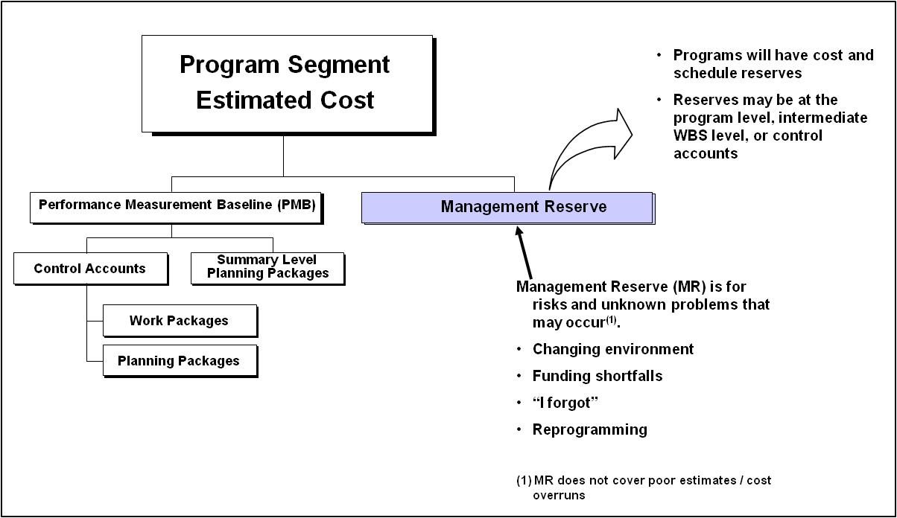
Figure 8: Performance Measurement Baseline Key Elements
Both reserves are identified at the beginning of the program and can be supplemented through a change in the program via an approved program PMB change request. Similarly, the use of reserves needs to be formally documented. Both the initial documentation and program control logs used to track the reserves are explained below.

Management Cost Reserve (MCR)
The Management (Cost) Reserve is documented in the program baseline control log. The total amount of the reserve is maintained at the program level and maintained in the baseline control log. The reserve is defined by the Program Manager. The amount should be relative to the program risk established at the planning phase. Guidance from the Agency can be used to establish an increased level of reserve that requires JRC approval for use.
In Figure 9 shown below, the schedule and cost reserve can be established at multiple levels.
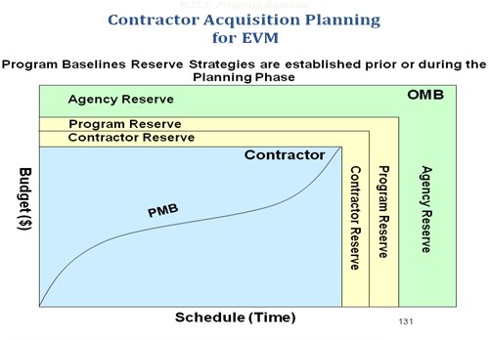
Figure 9: Contractor and Cost Reserves
Figure 10 is an example of Management Reserve as it is reported in the RAM:
Figure 10: Management Reserve in the RAM
Distribution of MCR to a control account needs to be documented in a program baseline control log. A program baseline control log can be used to track distributions of MR.
Figure 11 is an example of a program baseline control log that can be used to track distributions of MCR. Similar logs can be produced from most commercially available Earned Value software or can be developed in other spreadsheet products (e.g., Excel).
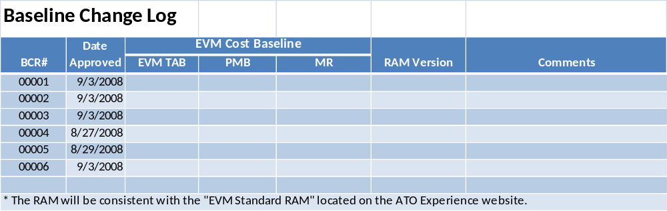
Figure 11: Baseline Change Log
Management cost reserve is usually not reported externally because the external reporting of program cost performance is done at the total cost baseline. Refer to the guidance for reporting reserves in the training for OMB 300 and the IT Dashboard.

Management Schedule Reserve (MSR)
Applying Schedule Reserve: Management Schedule Reserve, like MCR, may be established at both the JRC level as well as the PM level. The schedule reserve will be determined based on risk and used to provide a challenge to the program team managing the program.
Schedule Reserve is documented in the program control Log. This log is based on PMB and JRC committed baseline dates. The Program Management Office (PMO) is responsible for maintaining this report. It will identify the date reported for the program’s JRC schedule baseline as well as how much planned slack and what the actual forecasted slack is for the milestones.
The recommended schedule reserve log is provided in Figure 12. This format can be used to report management schedule reserve status to management. Refer to the EVM training material for additional guidance.
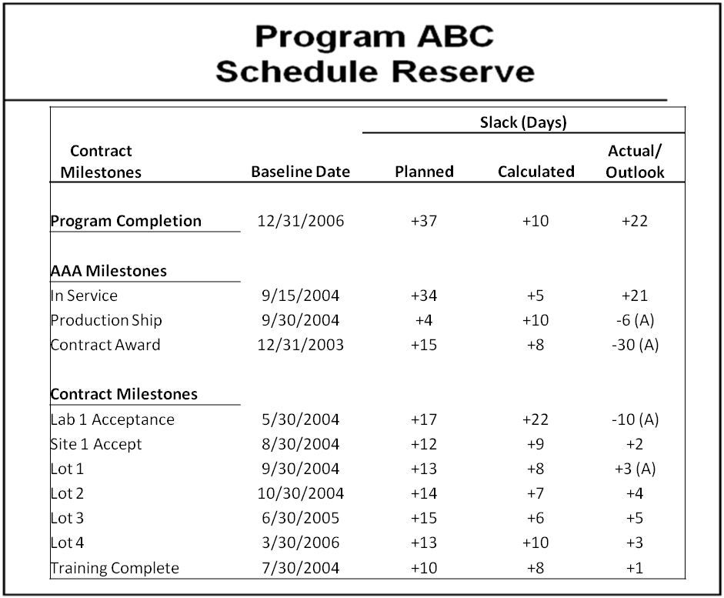
Figure 12: Schedule Reserve

Program Detailed Schedule
The control account plan (CAP) includes detailed schedules for the work assigned to the CAP. It is recommended that appropriated funding is planned in detail at the control account level. All effort required to complete the scope of work needs to be identified and scheduled. For near-term funded work, the activities should be planned at the work package level. Future work not well-defined may be planned as a planning package. Using the mix of detailed work package activities and planning packages is called rolling wave planning.
Rolling wave planning is a planning method where near term activities are detail-planned down to discreet activities and work that is not yet fully defined is scheduled as a planning package. This allows the PMO to focus on the detailing of the near-term work and not waste valuable resources and time trying to detail activities that are not well-defined.

Program Detailed Budgets
CAs are subdivided into PPs and WPs. Budget requirements and time-phasing are prepared for each WP and PP in accordance with the timing for the work planned in the program schedule. The CA budget is based on when the work will be accomplished or performed. The time-phasing of the budget may be generated from the resource loaded detailed schedule.

Work Authorization Document
Work Authorization Documents (WAD) are required to authorize work. Programs are encouraged to use existing FAA processes and documents to authorize work. Examples include a contract, funding authorization documents, and a control account approved by the program manager. See EVM training material for guidance for establishing work authorization documentation.

Earned Value Methods
Work package budgets are assigned earned value methods that will be used to record value of work accomplished. See EVM training material for guidance for assigning EVM methods to work package budgets.

PMB Change Control
Once the PMB has been established and agreed to by the program manager, the baseline is established and change control will be implemented so that any changes to the plan will be documented. The target for establishing the PMB is 90 days after the FID.
When the PMB has been approved by the program manager, supporting documentation may have to be updated to reflect the PMB. The PMB is usually reviewed with the program management team and concurrence is obtained to accept the scope, schedule, and cost baselines used for program performance reporting.
The PMB is documented in the program control logs and subsequent changes to the schedule and cost PMB are recorded and tracked in the program control log and the RAM.

FAA Program Analysis and Management Reporting
The following section describes the FAA and external stakeholder program performance reporting. The program performance reporting should be understood and used during the Organizing and Planning phases of EVM implementation to ensure the program control processes and procedures support the reporting requirements.
After the EVM PMB has been established and the program is executing and performing work, the program will monitor schedule accomplishments, technical progress, earned value, and cost incurred to determine program performance metrics that will be provided to the program manager, reported to FAA management, and reported to external management. These parties have different needs and, although the metrics may not be identical, they should be reconcilable. The program is responsible for maintaining and reporting program performance metrics to different stakeholders and must be able to justify and reconcile the differences to audit and review parties (i.e., FAA AIO, DOT, GAO, IG, and Congress).
The program performance metrics should be integrated with the risk management plan to identify technical, schedule, and cost risks. The program IT Dashboard cost/schedule table includes technical milestones and each milestone will have CAPs detailing the EVM plan to achieve the milestone. The EVM metrics should be used to identify schedule / cost risk candidates for these milestones.
It is recommended that the risk plan criteria for impact or consequence criteria include schedule metrics and cost metrics to identify risk candidates. The Schedule Performance Index (SPI), Cost Performance Index (CPI), Schedule Variance (SV), and Cost Variance (CV) are useful indicators to identify program risks.
The schedule management process should include an analysis of the program critical path to identify schedule risk candidates. The FAA EVM training material includes approaches for integrating EVM with the program risk management processes.

Program Status Reporting and Variance Analysis
During the Execution phase, the program uses the PMB and associated CAs to monitor program performance and develop earned value measures that are used to assist the program manager in quantifying program performance problems, issues, and risks. These earned value metrics are also used for the FAA Portfolio/Program Performance Metrics reported in SPIRE, the IT Dashboard milestone performance reported to OMB, the program performance reporting to the FAA EVM Focal Point Office, and the annual OMB program Exhibit 300 budget request reports.
The program establishes processes and procedures to gather PMB schedule performance, earned value claimed for work accomplished, and cost of work accomplished for all resources (contractor F&E and Government FTE) supporting the PMB. The program analyzes the control account’s EVM performance metrics, identifies potential issues / risks, and develops actions to mitigate risks, corrects performance deviations, or mitigates the impact to the program in the event the risk cannot be mitigated or the corrective action cannot be accomplished.
The PMB cost and schedule baseline may be different from the JRC / APB baselines. The PMB excludes the program schedule and cost reserves. The program must have processes in place to reconcile these baselines. The FAA EVM training material includes cost reconciliation exhibits that should be used. The FAA EVM training material also includes reports to reconcile the EVM schedule to the JRC/APB schedule baseline.
Figure 13 depicts the high-level process flow for the program execution stage. The associated descriptions of the high-level activities are described in the subsequent paragraphs.
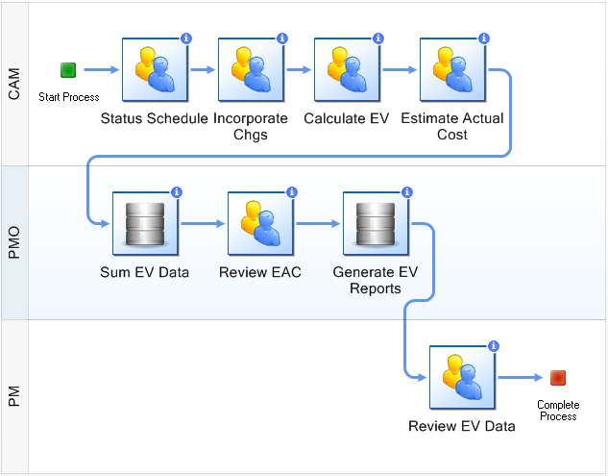

Figure 13: Execution Stage Process Flow

Status Program Schedule
At least monthly, the program will update the program schedule to:
- Record schedule accomplishments and identify schedule issues;
- Develop schedule issue workarounds; and
- Forecast schedule completion dates for key program milestones.
The program schedule management process should include focus on the milestones in the IT Dashboard cost and schedule table that is used to monitor technical progress and schedule performance.
Some of the program cost and schedule table milestones include the APB milestones and schedule performance will be reported in SPIRE. The monthly schedule update process should use CA schedule milestones.
If the program has contractor EVM or Integrated Master Schedule (IMS) reporting requirements, these inputs should be included in the program schedule update process.
The schedule update process should include WP activities because earned value is calculated at the WP level. The program status information is used to update WP status and integrate it into the EVM system for analysis reporting. This same information is used to report to executive management and program stakeholders. The FAA EVM training material includes instruction for claiming WP earned value.
Programs should have schedule management metrics that provide a measure of schedule status quality. Examples include:
- Percent of planned tasks, not started;
- Percent of planned tasks completions, not completed;
- Percent of tasks on the critical path and behind schedule; and
- Percent of CAs missing from the schedule update cycle.

Program Schedule Key Attributes
There are five primary attributes for ensuring that the program schedule updates support EVM and schedule performance reporting. These include:

Schedule Baseline
The schedule baseline and management schedule reserve must be defined and communicated to the program management team. The program schedule status reports must define the schedule baseline for which control account managers will be measured and variances will be monitored. Summary level planning packages schedule baselines will be defined and reported to management.

Actual Start/Finish Dates
The program schedule that is used for the PMB will include planned events that are required to achieve program cost and schedule table milestones. Early, late, and on-time planned start and completion for these activities are used to compute work accomplished that is reported using EV techniques.
The program should have processes in place to ensure the program schedule is consistent with the PMB and the schedule status is consistent with CA schedule milestones. The program should have controls in place to ensure errors are not included in the program schedule. Error examples include:
- Completed or in-progress tasks must have actual start dates; and
- Work packages that are 100% complete must have a completion date.

Forecast Start/Finish Dates
The program schedule includes deviations from the PMB schedule. These deviations may require workarounds or a revised outlook to get back on plan. The schedule management systems should include the forecast start and finish dates required to mitigate risks or to get back on plan.
The program should have controls in place to ensure the planned dates, sometimes referred to as baseline dates, are consistent with the PMB schedule. Any task or part of the task that is incomplete must have forecasted start and finish dates after the status date. These dates provide the latest view of the work to be completed. If improper status is reflected in the schedule, inaccurate earned value calculations will result.

Percent Complete
WP tasks used for earned value calculations must be included in the program schedules. It is important that a quantifiable measure of work accomplished be associated with a WP task completion, referred to as physical percent complete value. Many schedule management applications provide earned value metrics based on task duration. The FAA does not use task duration as a basis of earned value except for level of effort (LOE). Measurable WP tasks have EVM methods and measures that provide a measure of work accomplished.

Schedule Reserve
Programs may have a schedule reserve to accommodate program schedule risks that may be mitigated, or to accommodate events that were not planned. A schedule reserve provides a buffer to accommodate risks that cannot be mitigated and unplanned events that negatively impact schedule performance.
Normally schedule reserves are not reported to external stakeholders. The programs have to establish processes and techniques to track schedule reserves and to report schedule performance for PMB schedule baselines reported to FAA management and to report investment schedule baselines monitored by external stakeholders.
The FAA EVM training material includes techniques and reports for tracking and reporting schedule reserve status that supports reporting schedule performance for the PMB schedule baseline and the JRC / APB schedule baseline.

Program Schedule Changes
Changes to the PMB and JRC baseline schedule must be controlled and documented. Programs should use a Change Request (CR). An example of a CR form is provided in Section 6.1.2, Change Control Procedure. The program should have procedures in place to ensure the program manager approves PMB program schedule baseline revisions.

Earned Value Calculations
At least monthly, the program uses the schedule status for WP tasks to establish earned value calculations used to report percent complete for program performance and for milestone performance to FAA management and external stakeholders. The baselines used for internal FAA management reporting and external stakeholders may be different for the schedule and cost reserves established in the PMB.
Programs must have procedures in place to report consistent percent complete metrics to both FAA management and external stakeholders. Program and milestones variance explanations may include references to schedule and cost reserves.

Estimated Costs for Earned Value Work Accomplished
Monthly, the programs calculate earned value for work accomplished and the programs estimate the cost for the earned value work accomplished. Programs may have estimated costs for contractors based on performance reports, such as the Contractor Performance Report (CPR). For Government FTE costs, estimates are usually based on actual resources expended using the budgeted rates. Each program will put processes in place to determine resources expended. Some programs may have purchases that have to be estimated.
Programs are required to have processes for reconciling estimated costs to actual costs. It is recommended that the reconciliation be performed at least annually and adjustments made to the EVM performance data.

Summarized EVM Performance Measurement Data
Budgets, earned value, and estimated costs are summarized and segregated by CAs. The CA amounts are summarized by the IT Dashboard milestones. The EVM performance data will be analyzed and significant variances for CAs and program IT Dashboard cost and schedule table milestones will be explained with an explanation as defined by the program.
Normally, CA and program IT Dashboard milestones with EVM cost and schedule cumulative variances in excess of 10% require a variance explanation documented and submitted to the program. Each program will establish EVM variance reporting thresholds and reporting requirements. Common variance reporting requirements include:
- Root cause of the variance describing technical, schedule, or cost issues;
- Actions that can be taken to correct or recover from a variance condition;
- Estimated impact to the cost and schedule at completion, if corrective action cannot be accomplished; and
- Schedule and cost impact to the program if corrective action cannot be accomplished.
During the variance analysis cycle, the control account variances are analyzed and variance reports are provided to program management. Program IT Dashboard milestone variance analysis is conducted by the program based on the control account variance reports.
Variance analysis reports (VAR), schedule status, and corrective action plans are addressed in detail in periodic program review meetings, normally held monthly. Status is verified, decisions are documented, and action items are assigned and recorded in the meeting minutes. The variance explanations are used to support program performance variances reported to FAA management and external stakeholders.
Some common analysis techniques and methods are provided as follows:

Variance-At-Completion
An at-completion variance is calculated by subtracting the EAC from the Budget at Completion (BAC) [VAC=BAC-EAC]. This type of variance occurs when the current EAC data differs from the BAC. An EAC is changed because program events may have invalidated the current EAC. If cumulative-to-date actuals have exceeded the EAC, the EAC must be revised.
A variance to the current at-completion data is explained on the VAR if the variance exceeds the established threshold. CAMs are required to examine, and update as warranted, the EAC each month during the variance analysis process to ensure its accuracy.

Schedule Performance Index
The SPI is the ratio of the work accomplished as compared to the work planned [SPI=EV/PV]. The SPI can be plotted over time to graphically portray schedule performance trends. It can also be used to convert dollar schedule variances into months ahead or behind.

Cost Performance Index
The CPI is the ratio of the value of the work accomplished to the amount spent to accomplish the effort [CPI=EV/AC]. The CPI can also be graphically displayed over time to portray performance and can be used to calculate an EAC. These estimates are statistical in nature and assume a straight-lined continuation of the prior performance; they are useful in making projections and in validating EACs.

To-Complete Performance Index
The to-complete performance index (TCPI) is the ratio of the value of the work remaining to be accomplished to the estimated value or the effort expected to be spent to finish the task [TCPI=(BAC-EV)/(EAC)-AC)]. If the resultant ratio is greater than the cumulative CPI, the TCPI indicates that the efforts expended to finish the task must be completed more efficiently than before to avoid exceeding the EAC. If the ratio is less than the cumulative CPI, the TCPI indicates that the balance of the effort can be accomplished within the EAC, provided the balance of the task is performed as efficiently as before. The TCPI can also be graphically portrayed monthly to show performance trends.

EVM Statistical Forecasts
A statistical forecast using EVM CPI and/or SPI metrics is recommended to verify the reasonableness of the control account and SLPP estimates at completion. The typical EAC calculation adds the actual cost of work accomplished to the estimated cost of remaining work (estimate to completion - ETC). The ETC may be calculated using CPI / SPI EVM factors. See the EVM training material for guidance on calculated or statistical ETC’s.

Control Account Estimate at Completion
During the monthly review, the cost, schedule and technical impact at completion are assessed for control accounts. If the corrective action does not allow the current control account EAC to be achieved, the CA EAC should be updated. Also, as stated above, the EAC may be modified if the statistical forecasts generated by the EVMS are deemed unattainable. If the program manager believes that the control account EAC is unrealistic or unachievable, the control account EAC should be revised.
In developing and reviewing the revised CA EAC, the CAM must remember that the EAC is the estimated cost of work accomplished plus the estimated cost to complete the CA.
The program manager reviews the control account EACs and the variance analysis. The program manager’s review includes a schedule impact assessment of changed forecast dates by control account.

Generate Earned Value Reports
On a monthly basis, program reports need to be produced and made available to the program stakeholders. The most frequently used reports are the Program Summary Report (which satisfies the EVM Data Request from the EVM Focal Point Office), the Contractor Performance Report (CPR), and the control account variance analysis reports. The program specifies which reports are required.

Internal Review by Program Manager
The primary method of reporting program status and problem areas to management is through weekly, biweekly, or monthly reviews conducted by the program manager or designee. The preview includes the status of technical areas, report problems, and corrective actions being taken (e.g., the impact of workarounds, etc.) and indicates progress being made on outstanding action items.
Other internal reviews include a review of performance measurement data; significant variances, including workarounds and corrective action plans for critical activities affecting performance and EACs. Internal program reviews are supplemented by reviews conducted between program management and executive management that cover program progress, problems, and special interest information related to the program.
Managers at all levels are continuously involved with determining program and problem status for their respective areas of responsibility. By exchanging program information, both in reports and in meetings, all parties are apprised of the need to take action and the results of corrective actions.
Programs may take differing approaches to ensure that follow-up action is completed. At a minimum, monitor corrective action through the variance analysis process until closure is reached on all actions. Program managers may also choose to utilize a Corrective Action Log. The Corrective Action Log is used to track those items identified during the conduct of variance analysis to completion.

EVM Governance

Program Earned Value Management System Assessment Process
Once a program has been approved by the JRC and required adjustments are made to the existing artifacts, the PMB established for the program needs to be prepared for the Earned Value Management Program Performance Assessment. The assessment is conducted by the EVM Focal Point Office. This activity should be reflected in the CPIC POAM developed at the start of the Planning phase, or Initial Investment Decision, process.
The FAA Program EVMS Assessment is a process that involves the reviewing, validating, and verifying of the design and implementation of an EVMS. The assessments that meet the requirements of the 32 EVMS Guidelines embodied in the American National Standards Institute/Electronic Industry Alliance’s (ANSI/EIA) EIA-748, Standard for Earned Value Management Systems.
For a detailed understanding of what is conducted during the Program EVMS Assessment Phase 1 - Investment Analysis refer Figure 2.2.1 in the FAA EVM System Acceptance Guide found on FAST <http://fast.faa.gov/EarnedValueManagement.cfm>

Post FID EVM Assessment
The assessment of the FAA program’s EVMS continues during the Solution Implementation phase following the FID. After FID, the EVMS assessment reviews continue with the update of the pre-FID documentation to incorporate changes from the FID. After the Organizing and Planning assessments are complete, the assessment reviews for the Performing, Analysis and Reporting, and Baseline Change Management guidelines are conducted. The program’s goal is to complete all EVMS assessment reviews within 180 days of the FID.
The Program EVMS Assessment Phase II- Solution Implementation process and activities are outlined in Figure 2.2.2 in the FAAEVM Systems Acceptance Guide found on FAST <http://fast.faa.gov/EarnedValueManagement.cfm>

Note: Internal Link to Assessment criteria can be found at: <https://intranet.faa.gov/faaemployees/org/linebusiness/ato/acquisition_business/ipm/evm/>

Contractor System Acceptance
FAA AMS policy requires contractor EVM validation of ANSI/EIA 748 EVM Standard compliance for major programs for contractors with contracts over $10M. The objective of the contractor EVM System Acceptance process is for the supplier to demonstrate that its EVMS follows the guidelines of the ANSI/EIA 748 Standard – EVMS, as required by the contract. If a contractor has a third party assessment of compliance, it may be used if approved by the FAA EVM Focal Point Office. If an existing party assessment of compliance is not acceptable, the contractor will be assessed by the FAA. The contractor EVM System Acceptance review is conducted consistent with the FAA EVM System Acceptance Guide, found on FAST: <http://fast.faa.gov/EarnedValueManagement.cfm>
Integrated Baseline Reviews

Program Integrated Baseline Review (IBR)
Once the program has been approved, the Program Lead needs to begin preparation for a program IBR based on the schedule identified in the CPIC POAM. While the goal is to have the review at the most logical time in terms of the level of definitization, the IBR should occur sometime within the first 120 days after FID has been made.
The intent of the IBR is to provide FAA programs with guidance on the viability of the proposed baseline and to gain a mutual understanding of the assumptions and risks made in the planning of a program. The IBR is a program that:
- Verifies that the total program technical, schedule, resource, and cost baselines are achievable and risks have acceptable risk handling plans; and
- Verifies program management control processes and systems are in place to achieve program objectives and agency commitments.
The objective is to improve FAA program performance by ensuring that adequate planning and risk consideration have been performed in conjunction with an established PMB after JRC program or re-baseline approval. The IBR also serves to verify that the program management processes are integrated and an adequate and appropriate metrics management plan is in place to manage, monitor, and report program performance.
For more details on the internal Program IBR refer to the Program Level Integrated Baseline Review (IBR) Guide which can be found on the FAST website: <http://fast.faa.gov/EarnedValueManagement.cfm>

Contractor Level IBR
Once the program’s baseline has been validated and the assumptions and risks understood via the Program IBR process, the Program Lead conducts an IBR on all the major contractors for the program’s effort. These IBRs should be planned to correspond with the definitization of the work by the contractor, but usually should occur within 90 to 180 days of contract award. That timeframe will be dictated by the size and length of the contract, when the work is definitized and in coordination with the contractor.
It should be noted that while there will be an initial IBR at the beginning of the program, that does not preclude additional IBRs being conducted on the contractors’ baseline. In fact, IBRs will usually be conducted when there is a major change to the contract including additional awards to the contractor, or based on large portions of the work being definitized.
The process is similar to the program level IBR. However, the Program Lead replaces the EVM Focal Point Office for the program level IBR. The EVM Focal Point Office can support the program during its execution of the IBR.
For more details on the IBR process refer to the IBR guide on the FAST website: <http://fast.faa.gov/EarnedValueManagement.cfm>

Program Surveillance
Once the program is in the Solution Implementation phase of the program’s lifecycle, it is part of the ongoing program surveillance process utilized at the FAA. The goal of the surveillance process is to ensure that the Execution phase of a program is in compliance with the FAA EVM guidelines, which helps ensure better program management.
The FAA program performance surveillance will be conducted consistent with the FAA Program Surveillance Guide found on FAST: <http://fast.faa.gov/EarnedValueManagement.cfm>

PMB Revisions and Data Maintenance
Once the PMB is established, cost, schedule and technical changes are processed through change control procedures. This activity supports the execution stage and is the vehicle to approve and track changes to the PMB. This requirement, however, is in no way meant to discourage changes to the PMB. Instead, changes that reflect the most current program conditions are encouraged. Meaningful performance measurement data requires a PMB, which is documented and reflects the most current conditions of the program.

EVM PMB Change Control
The change control process is implemented after the FID and APB baselines are established. After the PMB is established the program control logs are maintained. These PMB baseline maintenance disciplines ensure that:
- Budgets are assigned to specific segments of work defined as CAs, WPs, and SLPPs;
- Scope is transferred from one organization to another or from one CA to another with the associated budget;
- Records are maintained to indicate when and where MR was applied;
- Retroactive changes to a budgets planned value, earned value, and actual cost, or CA/WP schedules are limited to correct errors or for normal accounting adjustments;
- Future PPs and WPs scheduled to start beyond the next reporting period may be rescheduled within the CA budget and schedule constraints; and
- Changes to the budget or schedule for open WPs require a BCR approved by the Program Change Control Board (CCB).
The change control process is required to ensure that only approved changes are incorporated into the EVM PMB baseline and are appropriately documented.
The Baseline Change Log provides traceability from the original baseline to the current baseline for all approved changes that have been incorporated. All changes are entered in the log and are appropriately discussed in the applicable reports. The program value reflected in the TAB is reconciled against the sum of all CA budgets and MR.
Baseline change requests are submitted to the program office for evaluation of the impact for the requested change. Impacts to schedules of other organizations are resolved prior to approval of the revision. Baseline changes are submitted to the CCB (or similar control board) for approval prior to implementation. Approved changes are incorporated in the RAM.

Types of Baseline Changes
Baseline changes may occur as a result of funding modification, formal reprogramming, internal re-planning, conversion of PPs, and the use of MR. The types of revisions that may occur to the baseline are broken into two key areas based on the level of approval required. Federal IT Dashboard Table II.A milestone changes require approval of the JRC or the program manager.
Table 14 defines the type of milestones revisions that require JRC or program manager approval:

Life Cycle Phase | Program Planning Template Attribute | JRC | PM
Acquisition | Scope/Structure
Acquisition | Additions/Deletions of Acquisition Phase Milestones | 
Acquisition | Schedule
Acquisition | Any (APB or Non-APB) Milestone Planned Start Dates |  | 
Acquisition | APB Milestone Planned Completion/Finish Dates | 
Acquisition | Non-APB Milestone Planned Completion/Finish Dates |  | 
Acquisition | Cost
Acquisition | EVM Total Allocated Budget | 
Acquisition | APB & Non-APB Milestone Costs |  | 
Figure 14: Milestone Revisions

JRC Approved APB Changes
JRC level APB changes require both the approval of internal Program Management and JRC. These changes are not implemented until JRC approval is provided. JRC level changes can be the result of funding modifications, re-baselining, or program re-planning.

Addition/Deletion of Acquisition Phase non-APB Milestones
Modification to the Federal IT Dashboard Table II.A non-APB milestones must be approved by the program manager.

Data Errors
When data errors occur, appropriate action is taken to determine whether the source of the error is human or systemic and to correct the problem. The CAM, in conjunction with the business manager, is responsible for correcting errors in earned value data to ensure that program status is accurately represented.
It is the responsibility of the CAM, the program manager, and the business manager to be accountable and ensure that no changes are being made to data simply to “hide” potential performance issues or avoid writing a VAR. Acceptable data errors may include situations where:
- Incorrect performance may have been taken. Perhaps the CAM took too much or too little performance, due to a data entry error or a misunderstanding of the baseline requirements. If the error is due to a misunderstanding or other foreseeable reason, steps must be taken in order to ensure the error is not repeated; and
- Actuals may be reported incorrectly due to an employee charging to the wrong charge code. This should be minimized by the CAM reviewing actuals data on a regular basis. When such errors occur, steps must be taken to ensure the error is not repeated.
Retro-active changes are prohibited with the exception of data errors. The following changes are accepted retroactively:
- Routine accounting adjustments;
- Definitization of contract actions;
- Rate changes;
- Economic price adjustments;
- JRC approved changes; and
- Data entry corrections.

The Change Control Process
Figure 15 depicts the high-level process flow for the change control process. The associated descriptions of the high-level activities are described in the subsequent paragraphs.
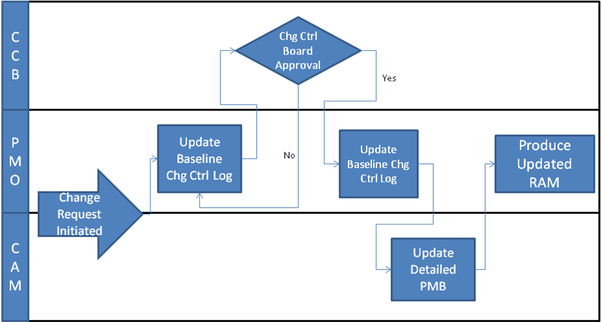
Figure 15: Change Control Process

Change Request Initiated
Changes to the PMB must be documented in a timely manner. All changes will be submitted into the change control process via a BCR form. The CCB reviews and approves all changes to the PMB. Changes will usually be initiated by a CAM or the program manager.
Figure 16 is an example of the Baseline Change Request (BCR):

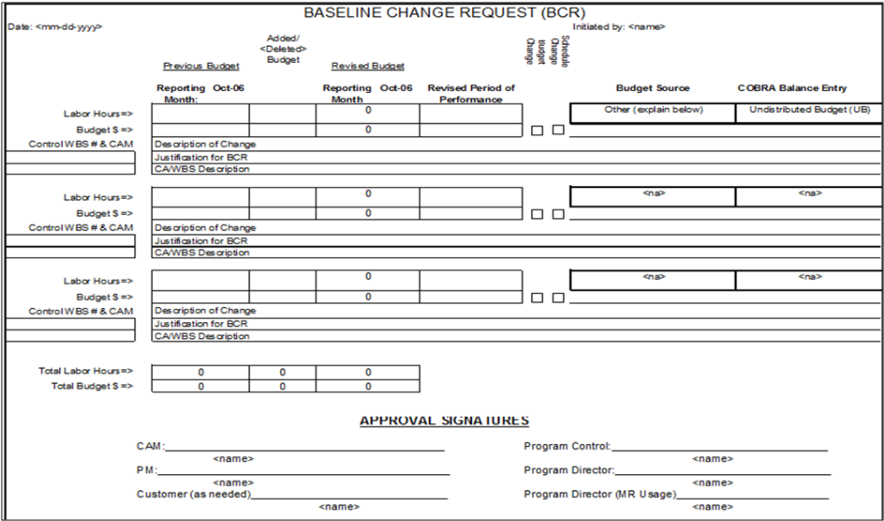
Figure 16: Baseline Change Request

Update Baseline Change Control Log
Once the BCR is completed, it is entered into the Baseline Change Control Log (BCCL) which tracks the high-level information about the requested change and where a unique identifier is assigned to the BCR. Once the BCR is recorded into the BCCL, it can be submitted to the CCB for review.
Figure 17 is an example of the Change Control Log is below:

Figure 17: Baseline Change Log

Approve/Disapprove Change Request
After receiving a completed BCR, the CCB evaluates the impact of the requested changes. Then, the request and its supporting documentation are reviewed for conformance to established processes, impact to other schedules, and the estimated dollar change. When schedule, scope, and budget issues are resolved, the CCB approves or disapproves the BCR.

Update PMB with Approved Revision
Once a revision has been approved, one or more CAs and/or the addition of new CAs may be needed. The revisions are incorporated into the RAM referenced in the baseline control log. Changes are incorporated into the baseline to reflect the approved request. The RAM documents baseline revisions to the cost/schedule baseline.

Produce Updated RAM
Once the approved BCR revision has been fully incorporated into the PMB, an updated RAM needs to be produced by the PMO to ensure it reflects the most current baseline.

Baseline Reconciliation
It is important that the PMB be reconciled with the other “baselines” and reporting levels associated with a program so a consistent program performance reporting is provided to management. The baseline reconciliation consolidates cost information and identifies differences between the different cost baselines used to report program performance to FAA and external oversight organizations such as DOT, GAO, IG, and OMB.
The summary report below is used to identify differences that may occur between the different cost baseline reporting artifacts for a program. This report compares all of the different artifacts back to the BCAR used for the FID.
The purpose of this reconciliation report is to identify potential issues, it is not a hard and fast rule that something shows as yellow in this report is wrong, but it does need to be investigated and understood. In the summary report shown in Figure 19, the following color-coding (Figure 18) is used to identify the status of the data:
Color Code | Definition
Yellow | Indicates there is a 2% difference, positive or negative, between the values being reported in a document compared to what is in the BCAR.
White | Indicates there is not a significant delta between the document reported in the column and the BCAR.
Grey | Indicates there is not a direct comparison that can be applied at the intersection between the document being reported and the BCAR.

Figure 18: Color-Coding
Figure 19 is based on an excel spreadsheet that contains the data from the key artifacts and then reports on the alignment between the different documents.
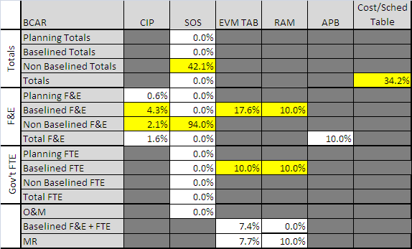
Figure 19: Summary Reconciliation Report
The matrix is organized to compare the different baseline related artifacts (CIP, Summary of Spending Table, EVM TAB, RAM, APB and Cost/Schedule Table) to the approved BCAR for the program. The BCAR information is broken down into the lower level buckets that can be compared to other artifacts the program uses to report. For example, the CIP only reports the F&E dollars for a program and does not contain Government FTEs or O&M dollars. For this reason, the matrix is designed to have a section that specifically reports the BCAR F&E dollars and their current status (planning, baselined, or non-baselined) so they can be compared directly to the values in the CIP.

When the Reconciliation Will be Used
The reconciliation process is conducted by the AIO Value Management Office/AJA at major reviews for a program. Figure 20 lists where the reconciliation should occur:
Program Review
Pre/Post FID EVM Assessments
Annual OMB 300 Updates
Annual Program Performance Surveillance
Integrated Baseline Reviews
Proposed AJA Reviews
Figure 20: When the Reconciliation will be Used

How the Reconciliation Will be Used
For each cell or intersection between a document and the BCAR that is highlighted in yellow, an investigation into why the cell is yellow needs to be conducted. It could be the case that the difference between the documents is known, understood, and does not represent a risk to the program.
Any discrepancies equal to or greater than 2% needs to be approved by the EVM Focal Point Office, the AIO Value Management Office lead and the AJF lead. The approval will be captured in the PMB Reconciliation Exhibit document. If the discrepancy is not approved, the artifact in which the difference exists needs to be corrected. A detailed step-by-step procedure for utilizing the PMB Reconciliation Exhibit will be provided with the document itself.

Earned Value Management Roles and Responsibilities
EVM requires the coordination of four key roles and the ability to effectively implement and report the schedule and cost performance of the technical accomplishments related to the FAA AMS standard program milestones. The four key roles are: Program Manager, CAM, Business Manager, and EVM Focal Point Office.

Program Key Roles

Program Manager
The program manager (PM) is an individual who has been assigned responsibility and authority for accomplishing program goals and scope as approved by the JRC. The program manager is typically responsible for the planning, implementation, controlling, and reporting of cost, schedule and technical performance on a particular program.
The program manager assumes overall responsibility for the implementation and use of an EVMS throughout the program for development, modernization, and enhancement activities as defined in AMS and documented in the JRC approved APB. Responsibilities include program planning, approving resource work authorization, manage funding, Management Reserve management (schedule and cost), and program performance reporting overview. The following is a list of specific responsibilities that are conducted by the PM:
- Guides and directs the development of the program WBS and the WBS Dictionary;
- Guides the establishment of the CAs and provides direction to the responsible managers;
- Approves the RAM used to document the PMB by CA and maps to the program IT Dashboard cost/schedule milestone table;
- Approves the program IMS used to plan and status schedule accomplishments;
- Approves the level of the schedule critical path reporting that identifies program schedule risks during the Solution Implementation phase;
- Approves schedule and cost reserves associated with the EVM PMB;
- Approves the EVM PMB that will be used to report program cost, schedule and technical performance;
- Approves changes to the PMB;
- Establishes PMB controls to ensure the PMB is current and reflects JRC approved scope and funding authorized for the program as defined in the CIP and by OMB;
- Reviews analysis of cost/schedule table milestone significant variances;
- Approves PMB EACs reported to FAA management and external stakeholders;
- Coordinates the program level IBR;
- Conducts prime contractor IBRs;
- Approves FAA program performance surveillance reports;
- Conducts prime contractor EVM surveillance; and
- Provides FAA management and external stakeholders with early warning cost and schedule EVM metrics and trends.

Control Account Manager
The CAM is a member of the program team assigned by the program manager and is documented in the RAM. The CAM is responsible for the budget and schedule associated with the CA technical scope. The CAM is responsible for reporting CA EVM cost, schedule and technical performance. A CA can have only one CAM. Specifically, a CAM:
- Concurs with the CA scope, schedule, and budget documented in the RAM;
- Supports the development of the program IMS by developing CA detailed schedule activities required to accomplish the CA scope within the schedule documented in the RAM;
- Reviews and concurs with CA earned value and schedule status, while conducting variance analysis to support the program variance analysis for cost/schedule table milestone variance reporting;
- Establishes WP EVM methods that provide reliable measures of technical work accomplished and EACs; and
- Supports the program level IBR.

Business Manager
The business manager provides support to the program manager and the CAM in the planning and implementation of EVM processes and tools. Specifically, the business manager:
- Coordinates with the program manager and the CAMs to develop the WBS, the WBS Dictionary, and the RAM;
- Develops the program IMS used to plan and provide schedule status for CAs, WPs, and cost/schedule table AMS standard program milestones;
- Conducts schedule critical path analysis to identify schedule risk candidates;
- Coordinates the development of the program PMB budget and the RAM;
- Maintains the EVM PMB control log;
- Maintains the EVM PMB change control process;
- Supports the program level IBR; and
- Supports the prime contractor IBR

Investment Decision Authority
The JRC approves the program segments and associated APB that the program manager is responsible to execute within the parameters as defined in the APB. The JRC Executive Secretariat maintains the official repository of investment decision documentation and records of decision, such as the BCAR and ISPD.

Appendix A: GAO Seven Components of an Effective EVM Policy

Assessment of FAA’s EVM Policies and Procedure Compliance with GAO EVM Best Practices
GAO EVM Best Practices | FAA Compliance | FAA References
#1 Clear criteria for implementing EVM on all major IT investments | The FAA AMS policy requires earned value management (ANSI/EIA 748 compliant) for program implementation for all major programs as defined by OMB and for major program prime contractor contracts over 10 million dollars. | AMS Policy 4.16.1 Program Requirements and  AMS Policy 4.16.2 Contract Requirements on FAST:  Section 4.16 Earned Value Management
#2 Compliance with the ANSI standard | The FAA EVM System Description describes the FAA process, procedures, and requirements for the implementation of EVM within FAA. In order to verify compliance with the ANSI standard, the FAA EVM policies and system description are reviewed by EVM subject matter experts, external stakeholders, and industry EVM professional organizations. FAA conducts ANSI compliance reviews for all major programs and for major program contracts over $10M.  The FAA has developed FAA Program Control EVM Assessment Review Criteria that describes FAA EVM attributes and documentation required for ANSI/EIA 748 EVM Standard compliance.  FAA has an EVM Systems Acceptance Guide that is included with AMS Guides. | AMS Policy 4.16.1 Program Requirements and  AMS Policy 4.16.2 Contract Requirements on FAST: Section 4.16 Earned Value Management  Contact EVM Focal Point Office for specifics on FAA Program Control EVM Assessment Review Criteria.  AMS Policy Section 4.16 EVM Reference Documents; FAA EVM System Acceptance Guide on FAST: <EVM System Acceptance Guide>
#3 Standard structure for defining the work products | FAA AMS requires FAA major programs to use the AMS FAA standard work breakdown structure and AMS standard program milestones for internal and external program performance reporting. FAA provides training and guidance for obtaining prime contractor EVM performance reports consistent with program WBS and standard milestone program performance reporting requirements. | AMS Policy Lifecycle Acquisition Management Policy on FAST:  Lifecycle Acquisition Management Policy  Contact EVM Focal Point Office for specifics on training.
#4 Integrated baseline review | The FAA AMS requires integrated baseline reviews for major programs and related prime contractor contracts over $10M. The FAA has an IBR guide that is included with AMS Guides. | AMS Policy Section 4.16 EVM Reference Documents; FAA EVM Integrated Baseline Review Guide on FAST: <EVM IBR Review Guide>
#5 Training requirements | The EVM System Description provides EVM training offerings. The FAA offers EVM Basic Training and Advanced Training courses. The FAA Advanced training provides the methods and techniques used by the FAA. | Contact EVM Focal Point Office for specifics on training.
#6 Rebaselining criteria | The FAA EVM System Description describes how EVM performance measurement baselines are established, managed, and controlled. The FAA EVM System Description includes rebaseline guidance consistent with the OMB IT Dashboard and the FAA AMS. | Refer to AJF Baseline Management Procedure.
#7 System surveillance | The FAA AMS requires systems surveillance for FAA major programs and related prime contractor contracts over $10M. The FAA has a Program Performance Surveillance Guide that is included with AMS Guides. | AMS Policy Section 4.16 EVM Reference Documents; FAA EVM Surveillance Guide on FAST: <EVM Surveillance Guide>

Appendix B: RAM Template

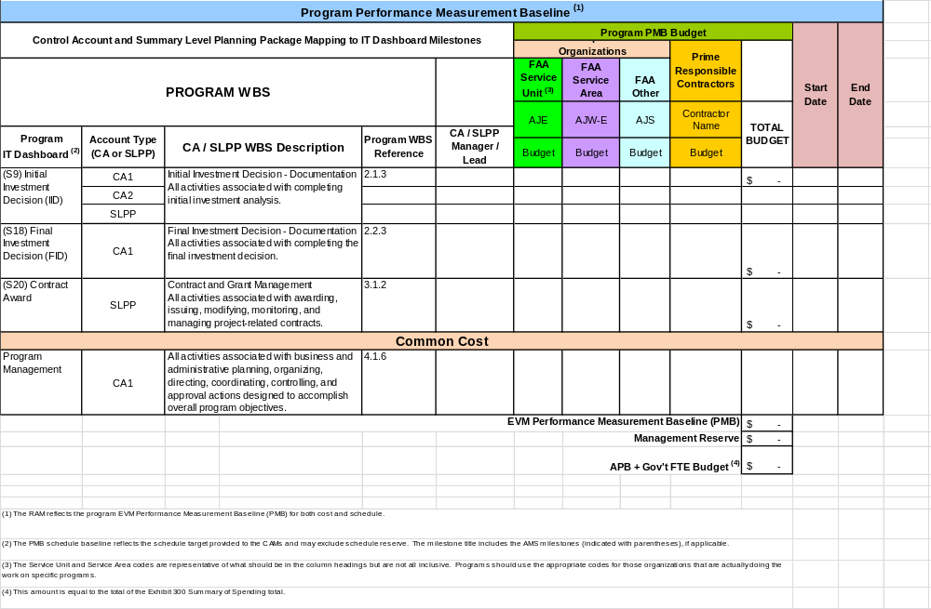

Appendix C: Program Planning Template

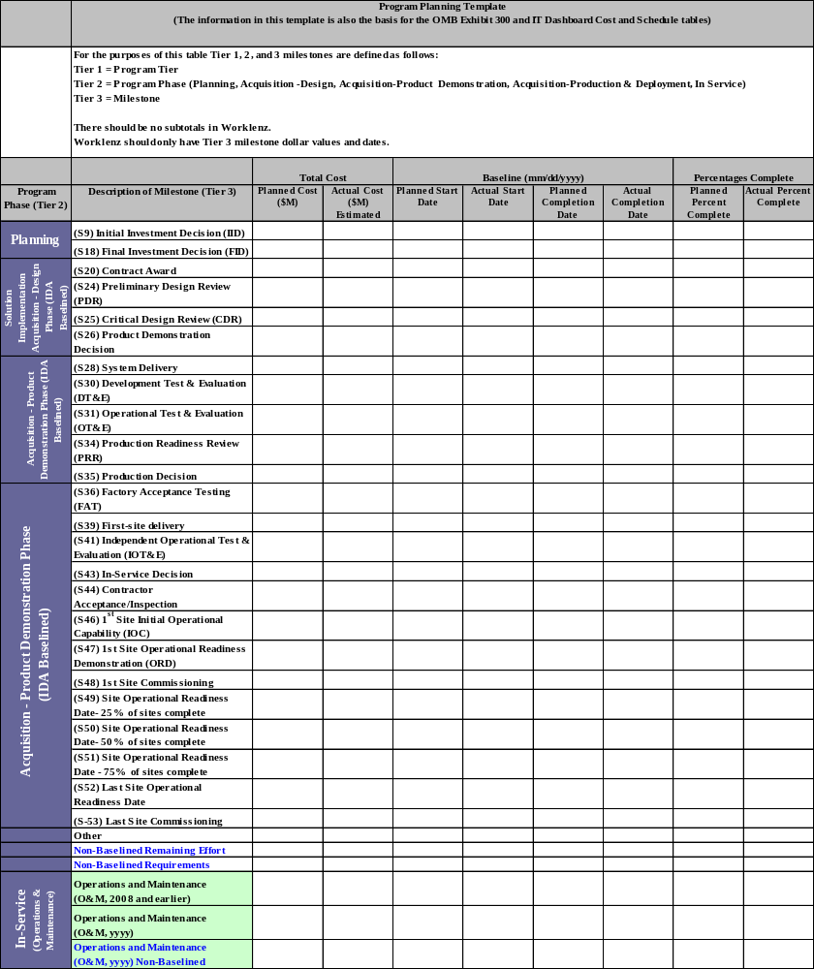

Appendix D: EVM Standard Terms and Definitions

EVM Standard Terms and Definitions
Acquisition Program Baseline (APB): Establishes the performance to be achieved by an investment program, as well as the cost and schedule boundaries within which the program is authorized to proceed. The acquisition program baseline is a formal document approved by the investment decision authority at the final investment decision, and is a contract between the FAA JRC and the program manager of the service organization.
The APB domain is Solution Implementation and as such it does not include the baseline costs incurred prior to the Final Investment Decision nor does it contain the operations costs associated with In-Service Management. The APB consists of three interdependent acquisition baselines: schedule, cost, and scope. The schedule and scope attributes of the APB are identical to the Solutions Implementation schedule and scope for all JRC approved segments. The APB cost includes the total F&E costs associated with the Solutions and Implementation phase of JRC approved segments.
EV Guidance: The APB and the PMB have identical scope attributes. There is a one-to-one match between the scheduled planning template milestones, but the dates in the PMB can reflect management challenges defined by the PM and therefore be earlier than the APB dates. The cost attribute of the APB differs from the PMB in that the APB does not include Government FTE’s and does not break out Management Reserve.
Actual Cost of Work Performed (Actual Cost): Actual costs incurred and accrual (estimated) for accomplishing work performed (and correlated to earned value recorded) during a time period.
APB Planned Completion Dates: The APB Planned Dates for the Acquisition Performance Baseline are the APB scheduled milestone dates and are tied to the Program Planning Template. These dates are approved by the JRC and can only be revised by the JRC.
APB Proposed Completion Dates: The APB Proposed Dates in SPIRE are the forecasted or proposed dates when a scheduled milestone will be completed and are tied to the Program Planning Template. These dates are approved by the PM.
Apportioned Effort: Effort that by itself is not readily divisible into short-span work packages but is related in direct proportion to measured effort. Typically this effort is dependent on another task that can be measured discretely. Examples are quality support that is dependent on testing.
Budget at Completion: The total authorized budget (or planned value) for accomplishing the program scope of work. It is equal to the sum of all allocated budgets to control accounts or summary level planning packages. Management Reserve is not included. The Budget at Completion will form the Performance Measurement Baseline as it is allocated and time-phased in accordance with program schedule. For contractual effort the budget a completion will include undistributed budget.
Budgeted Cost for Work Performed (Earned Value): The budget value of completed work expressed in terms of the budget assigned to that work.
Budgeted Cost for Work Scheduled (Planned Value): The program (or contract) authorized budget assigned to the work to be accomplished for the program (or contract) work breakdown structure.
Business Case Analysis Report (BCAR): The BCAR summarizes the results of investment analysis, providing summary cost, schedule, and benefit information for each alternative solution to mission-need for use by the investment decision authority (JRC) when making initial investment decisions (IID) and final investment decisions (FID).
Capital Planning and Investment Control (CPIC): The process used by FAA management to identify, select, control, and evaluate proposed capital investments. The CPIC process encompasses all stages of capital management including planning, budgeting, procurement, deployment, and assessment. Within the FAA, the Acquisition Management System is the CPIC process.
Control Account (CA): A management control point where scope, budget, cost, and schedule associated with lower level work packages are integrated to enable performance measurement. A control account is comprised of work packages and planning packages.
Control Account Manager (CAM): The manager within the contractor’s organizational structure that has been given the authority and responsibility to manage one or more control accounts for technical, schedule, and cost management.
Cost Performance Index (CPI): A measure of cost efficiency on a project. It is the ratio of earned value (EV) to actual costs (AC). CPI=EV divided by AC.
Cost Variance (CV): A metric for showing cost performance derived from earned value data. It is the algebraic difference between earned value and actual cost (cost variance = earned value - actual cost.) A positive value indicates a favorable condition and a negative value indicates an unfavorable condition. It may be expressed as a value for a specific period of time or cumulative to date.
Discrete Effort: Work which can be directly measured and is related to the completion of specific end products or milestones.
Estimate at Completion (EAC): The estimated PMB total cost for all authorized work. Equal to the sum of actual costs to date (including all allocable indirect costs), plus the estimated costs to completion (estimate to complete).
EVM Guidance: The PMB EAC excludes management cost reserve.
Estimated Lifecycle Cost: The total cost to the FAA or acquiring, operating, maintaining, supporting, and disposal of systems or services over their useful life. Lifecycle cost includes all appropriations, RE&D, F&E, and O&M.
EVM Guidance: Note: Not all programs are going to have RE&D. NextGen is an example of a program that has RE&D. The Performance Measurement Baseline is derived from the Solution Implementation approved segment of the Lifecycle Cost.
EVM Performance Measurement Baseline (PMB): The Performance Measurement Baseline (PMB) is the time-phased plan established by the PM for executing the JRC approved program for EVM Performance.
EVM Guidance: The PMB represents the total time-phased budget against which program performance is measured and reported to both FAA internal management and external management, through avenues such as SPIRE, the EVM Focal Point Office Report, and the OMB IT Dashboard/E300. The PMB is the Solution Implementation (Acquisition) Cost Baseline for all JRC approved segments to date, adjusted for cost and schedule reserves. The PMB includes F&E funding plus Government FTE funding.
EVM Total Allocated Budget (TAB): The total allocated budget for the acquisition segments approved by the JRC.
In-service management phase: The In-service management phase of the lifecycle management process, is that period of time after a product or service begins operational use, and continues for a long as the product is in use.
Integrated Baseline Review: Verifies that the total program technical, schedule, resource, and cost baselines are achievable and risks have acceptable risk handling plans. Verifies program management control processes and systems are in place to achieve program objectives and Agency commitments.
Investment Program: A sponsored, fully funded effort initiated at the final investment decision of the lifecycle management process by the investment decision authority in response to a priority agency need. The goal of an investment program is to field a new capability that satisfies performance, cost, and schedule targets in the acquisition program baseline and benefit targets in the business case analysis report. Typically an investment program is a separate budgeted line-item and may have multiple procurements and several projects, all managed within the single program.
Level of Effort: Effort that is not easily tied to a discrete/measurable deliverables and is not related to the completion of specific end products. Examples are project management and engineering support.
Lifecycle: The entire spectrum of activity for an FAA capital asset starting with the identification of need and extending through design, development, production or construction, deployment, operational use, sustaining support, and retirement and disposal.
Management [Cost] Reserve (MR): Management Reserve is an amount of the program budget set aside for unforeseen risks and events associated with in-scope requirements that become realized in the future. The Program Manager will establish MR after consideration of all identified risks. Where possible, quantitative analyses of high impact and/or high probability risks will be performed to better understand the potential time and financial impacts to the program if the risks do occur.
Planning Package (PP): A holding account (within a control account) for budget for future work that is not yet practicable to plan at the work package level. The planning package budget is time-phased in accordance with known schedule requirements (due dates) for resource planning and the plans are refined as detail requirements become clearer and the time to begin work draws nearer.
PMB Baseline Replan: The Baseline Replan at the PMB is the realignment of remaining schedule and/or reallocation of remaining budget within the JRC approved segment(s) schedule and cost baseline. It is to be accomplished within the JRC - approved APB constraints. A replan requires the approval of the program manager.
Product Team (PT): A team with a mission, resources, leader, and cross-functional membership, which executes an element of a service organization's mission.
Program Manager (PM): The Program Manager is responsible for the planning and execution of a program. The PM is responsible to manage an investment within the parameters of the Acquisition Program Baseline (ABP) and the EVM Performance Measurement Baseline (PMB). Responsibilities include:
- Management of cost, schedule and scope of the program;
- Reporting variances against baselines to internal management and external stakeholders; and
- Control program replanning and obtain JRC approval for rebaselines.
Rebaseline: Changes to the baseline that would impact the total cost, schedule or past performance would require prior approval from the JRC.
Responsibility Assignment Matrix (RAM): The RAM correlates the program (or contract) control accounts to the organization responsible for the assigned tasks. It is created by intersecting the responsible organizations, control accounts or summary level planning packages or milestones.
Rolling Wave Planning: A process of detail planning near term effort when the requirements are more defined, while leaving future work rolled up to a higher level in planning packages. The wave is the time span defined either by a set number of reporting periods or between major milestone events. That time span moves out with the updating of the status date or the completion of the milestones. As the “wave” moves forward, planning packages will fall within that time span and will need to be detailed planned. This process applies at both the program level as well as the control account level.
Schedule Performance Index (SPI): The SPI is a schedule performance efficiency metric that measures the actual work accomplished as compared to the planned value of scope or work. The formula for the SPI is: SPI = BCWP / BCWS or Earned Value / Planned Value.
Schedule Reserve (SR): Schedule Reserve is the approved time period which is withheld for management control purposes and for changes in the Performance Measurement Baseline (PMB) that are the result of realized risks to the completion date. Schedule Reserve differs from float/slack in that it is managed at the program-level and not the schedule/task level. The Program Manager will establish SR after consideration of all identified risks. Where possible, quantitative analyses of high impact and/or high probability risks will be performed to better understand the potential time and financial impacts to the program if the risks do occur.
Schedule Variance (SV): A metric for the schedule performance derived from earned value metrics. It is the algebraic difference between earned value and the budget (schedule variance = earned value – planned value). A positive value is a favorable condition while a negative value is unfavorable. It may be expressed as a value for a specific period of time or for cumulative to date.
Solution implementation: Solution implementation is the phase of the lifecycle management process that begins after the investment decision authority selects a solution and establishes an investment program. It ends when the new capability goes into service. This phase is led by the service organization assigned by the JRC at the investment decision.
Summary Level Planning Packages (SLPP): A SLPP is a higher level account used to establish a high level holding account for budget that is identified to work scope; but which, for business reasons, is not yet allocated to Control Accounts (CA).
Undistributed Budget (UB): A temporary holding account for budget for authorized work that has not yet been planned in detail at the control account or summary level planning package level. The FAA normally uses UB at the contract level only.
Variance at Completion (VAC): The difference between the budget at completion and the estimate at completion is VAC = BAC - EAC. It may be calculated at any level from the control account up to the total contract. It represents the amount of expected overrun (negative VAC) or underrun (positive VAC).
Work Package (WP): A subdivision of control accounts, a work package is simply a task/activity or grouping of work. A work package is the point at which work is planned, work accomplished progress is measured, and budgeted cost for work performed (BCWP) is computed.

All revisions approved by the program manager must be coordinated with AIO.
APB & Non-APB Milestone Planned Start Dates can be revised with approval by the program manager as long as the task has not started.
APB Milestone Completion/Finish Milestone Date revisions must be approved by the JRC.
Non-APB Milestone Completion/Finish Date revisions can be approved by the program manager.
Revisions to the EVM Total Allocated Budget must be approved by the JRC.
APB & Non-APB milestone cost revisions can be approved by the program manager as long as the changes do not impact the EVM Total Allocated Budget and does not reallocate budget between F&E and Government FTE’s.

