
Acquisition Management System Guidance

FAA EVMS Surveillance Guide

July 2016

RECORD OF CHANGES

CHANGE  NUMBER | DATE | NUMBER OF FIGURE, TABLE OR PARAGRAPH | A*  M  D | TITLE OR BRIEF DESCRIPTION | CHANGE  REQUEST  NUMBER
01Guide Update | 3/23/2016 | Complete Document | M | Changes made to support July 2016 AMS EVM Policy update. | 16-33A
02
03
04
05

*A – ADD, M – MODIFIED, D - DELETED

TABLE OF CONTENTS

1.0 INTRODUCTION 4
1.1. PURPOSE 4
1.2. BACKGROUND 4
1.3. SCOPE 4
2.0 Surveillance PROCESS 5
2.1. SURVEILLANCE OVERVIEW 5
2.1.1. Surveillance Approach 5
2.2. SURVEILLANCE PROCEDURES 6
2.2.1. Contractor and FAA In-House EVM Surveillance 6
2.2.2. Surveillance - Primary Phase 11
2.2.3. Surveillance - Secondary Phase 13
2.2.4. Surveillance Summary Findings and Recommendations 15
2.3. WORK PRODUCTS/ METRICS 17
2.3.1. Surveillance Work Products 17
2.3.2. Surveillance Metrics 18
GLossary of terms 19

INTRODUCTION

Purpose

The intent of this guide is to establish the process for the conduct of surveillance for

- FAA program office’s EVMS that is undergoing surveillance
- FAA contractor’s EVMS that is undergoing surveillance

The objectives of this guide are to:

- verify compliance with FAA policies related to program or contract performance.
- verify program or contract performance data reliability and consistency.
- verify compliance with documented program or contract EVM Program Control Plan processes.

The programs selected for surveillance are coordinated with the EVM Council. Recommendations and corrective actions resulting from the program surveillance are approved and coordinated with the EVM Council. The contracts selected for surveillance are coordinated with the Program Office, contracting officer and EVM Focal Point (EVMFP).

Background

The FAA EVM Focal Point in consultation with the Line of Businesses is responsible for conducting program or contractor performance reviews and assessments. The assessment results will be reported to the Joint Resources Council (JRC), as required. Surveillance is intended to assure that FAA programs and FAA management can use, with confidence, the program or contractor performance data being reported.

The surveillance process is metrics-based and structured to use existing program or contractor performance reports, review documentation, and databases. The process is structured into two phases: Primary Surveillance and Secondary Surveillance. The Primary Surveillance Phase considers the performance of major FAA programs (investments) or contracts to determine if further surveillance is required. The Secondary Surveillance Phase includes more extensive surveillance for those programs or contracts that are selected as a result of the Primary Surveillance Phase.

Program managers are responsible for action items and recommendations for their programs or contracts. The EVM Council may establish working groups to address program or contract performance process and procedure issues.

Scope

This guide provides procedures for conducting program or contractor surveillance for the solution implementation phase after final investment decisions. Surveillances are performed continuously during the solution implementation phase on major programs or contracts (with validated EVMS) and a selection of high-dollar or high-interest non-major programs. Surveillance normally will not be conducted for the operational steady state phase of a program or contract unless the nature of the work lends itself to performance management using EVM.

Surveillance PROCESS

Surveillance Overview

The Surveillance Team is responsible for planning and coordinating annual FAA program or contractor surveillance. The EVMFP is responsible for conducting and reporting FAA contractor EVM surveillance, which will be used by the surveillance team. Figure 2.1 is an overview of the Surveillance process. It illustrates the high level surveillance processes and the responsible organization. Each process is further described in this document with a process flowchart and step/activity descriptions.

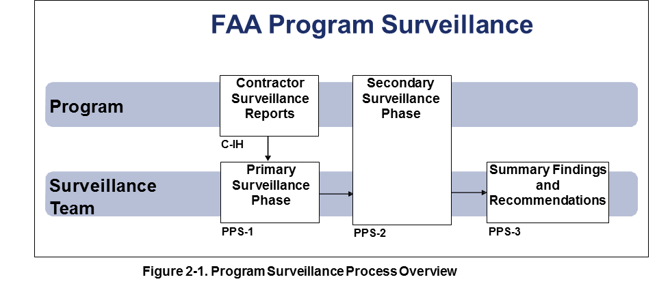

Surveillance Approach

FAA EVMS surveillance is intended to ensure policy compliance and data reliability across major, non-major programs or contracts. Data reliability includes verifying performance data consistency across data sources and reasonable data relationships between reporting periods. The process provides for high level oversight as the focus of primary surveillance for FAA programs or contracts and includes the review of results from previously conducted contractor surveillance activity (as described in section 2.2.1). Program specific issues discovered during primary surveillance may result in a more detailed secondary surveillance for selected programs or selected contracts.

The criteria for identifying the subset programs that require secondary review include:
- Multiple findings of data inconsistencies within a program or contract.
- Multiple findings of functional data inconsistencies across programs, such as schedule management.

The phased approach provides an overview for major, non-major programs or contracts, leading to a detailed surveillance for programs and contracts experiencing policy compliance or data reliability issues.
A brief description of the surveillance phases are as follows:

Primary Surveillance Phase. The primary phase is a scan of high level program or contract performance data to identify FAA programs that may have AMS policy deviations or unreliable program performance data. The source for program or contract performance metrics for the primary phase include documents such as program EVM reports, FAA contractor EVM surveillance reports, contractor performance reports, the Simplified Program Information Reporting and Evaluation (SPIRE) , service level review reports, external reports (IG/GAO), and OMB Major IT Business Case reports. The primary program or contract surveillance phase identifies candidates for a more detailed secondary surveillance review. The criteria for selecting programs for secondary surveillance are based on findings of issues with AMS policy compliance or questionable reliability of program performance data. These findings, along with a list of programs recommended for secondary surveillance will be reviewed and approved by the EVM Council.

Secondary Surveillance Phase. The secondary phase is an extensive review of existing program or contractor performance metrics from program or contractor documentation. The additional sources for program performance metrics for the secondary phase include documents such as program schedule, program management review charts, program baseline control logs, IBR reports, and other EVM program management related documents, reports, and management and analyst discussions. Action items from secondary surveillance for FAA programs are monitored and reported to the EVM Council.

Surveillance Procedures

The following provides a process flowchart, steps, responsibilities and process step descriptions for conducting and supporting program surveillance.

Contractor EVM Surveillance

The EVMFP is responsible for ensuring that FAA contractor EVM surveillance is conducted consistent with FAA AMS policy. Program surveillance requires surveillance reviews and reports for contractors resources that provide technical (e.g., training and testing) support to the program. Findings from the contractor surveillance will be used by the surveillance team during the primary surveillance phase. Figure 2.2.1 illustrates the process to conduct contractor surveillance.

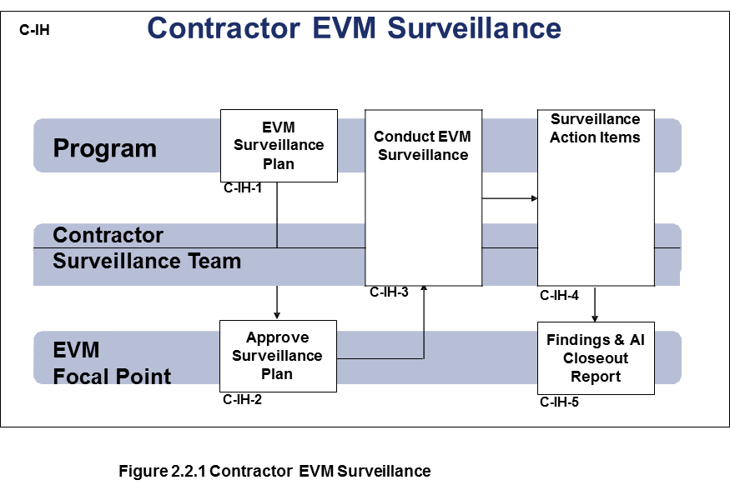
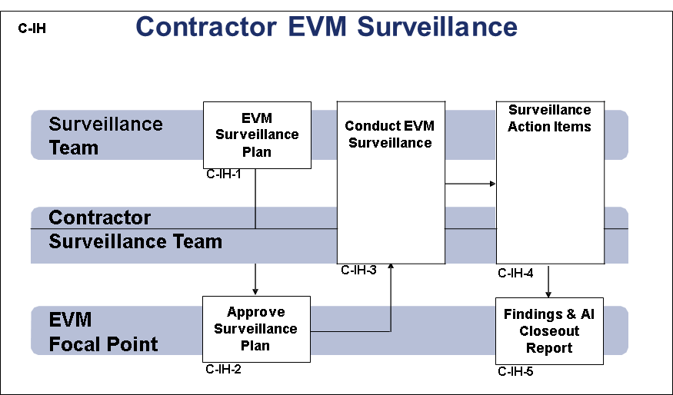

Figure 2.2.1 Contractor EVM Surveillance

C-IH Step | Responsibility | Process Step Description
EVM Surveillance Plan (C-IH-1) | EVMFP Office | The EVMFP Office is responsible to conduct contractor EVM surveillance.  The EVMFP Office develops EVM surveillance plans using the National Defense Industrial Association, Integrated Program Management Division (IMPD) , Surveillance Guide as a reference  Implementation Guidance:  EVM Surveillance planning activities include:  - EVM surveillance should be conducted for contractors with responsibilities for producing or delivering products and services that are measurable for technical accomplishments toward technical milestones, such as, the AMS standard acquisition program milestones.  - Support contractors providing staff augmentation services usually are not subject to EVM surveillance.  - Programs are encouraged to develop metrics based surveillance with primary and secondary phases similar to the FAA program surveillance process.  - EVMFP is responsible for coordinating the overall EVM surveillance for all organizations providing resources with responsibilities for producing or delivering products and services that are measurable for technical accomplishments.  - EVMFP in collaboration with program office and contracting officers are responsible to conduct EVM surveillance for contractors with an EVM reporting requirement.  - EVMFP is responsible for conducting EVM surveillance for FAA organizations required to report EVM performance  - Joint contractor / government surveillance is greatly encouraged.  - EVM surveillance by a qualified third party, such as DCMA or a contractor, is permitted.
Approve Surveillance Plan (C-IH-2) | EVM Focal Point | The EVM Focal Point reviews and approves the contractor surveillance plans provided by the Surveillance Team or EVMFP office. Throughout the planning and surveillance activities, the EVM Focal Point provides subject matter expertise t for planning and conducting contractor EVM surveillance.  Implementation Guidance:  - Revisions to contractor surveillance plans are approved by the EVM Focal Point  - Programs are encouraged to use lessons learned and continuously improve contractor EVM surveillance
Conduct EVM Surveillance  (C-IH-3) | Surveillance Team | Program Managers and the contracting officer conduct EVM surveillance consistent with the approved EVM surveillance plan.  Implementation Guidance:  - EVM Focal Point will assist with conducting EVM surveillance in addition to the EVM Surveillance team which consists of EVMFP Office and Collateral duty SMEs from LOBs as appropriate.
Conduct EVM Surveillance  (C-IH-3) | Contractor | The contractor participates and supports EVM surveillance.  Implementation Guidance:  - The surveillance plan should include a process for the contractor to review and concur with surveillance:  - Findings  - Action Items  - Action Item closeout procedure
Surveillance Action Items  (C-IH-4) | EVMFP | EVMFP In working with the Program Office and CO is responsible for obtaining concurrence for the contractor for surveillance findings and action items.  Implementation Guidance:  - The service organizations coordinate lessons learned from the findings and recommendations across all programs.  - The findings and action items are summarized to support the FAA program surveillance process and should be summarized by:  - Policy compliance issues  - Data credibility issues  - The schedule for closing action items will be coordinated, as much as possible, to support the FAA program surveillance schedule.
Surveillance Action Items  (C-IH-4) | Contractor | The contractor is responsible to take action to close out the action items consistent with the AI close out schedule.
Findings and Action Item Close-out Report  (C-IH-5) | EVM Focal Point | The EVM Focal Point monitors and summarizes results for contractor EVM surveillance. Action item close-out status is reported on a regular basis to the EVM Council.  Implementation Guidance:  - Lessons Learned from contractor EVM surveillance are used to continuously improve EVM surveillance.

2.2.1.1 FAA In-House EVM Surveillance RESERVED

Program Performance Surveillance - Primary Phase

The EVMFP Office prepares the program surveillance strategy that is approved by the EVM Council. The Surveillance Team is selected from the EVMFP Office and other FAA collateral duty SME FTEs as assigned. The surveillance team conducts the primary performance surveillance phase using information reported by programs and data included in systems such as SPIRE, service level reviews, external reports (IG/GAO), OMB Major IT Business Case reports, contractor performance reports, contractor surveillance reports, and program EVM reports. The findings from the primary surveillance are used to recommend the secondary surveillance plan which is approved by the EVM Council. The program surveillance primary phase process is illustrated in figure 2.2.2.

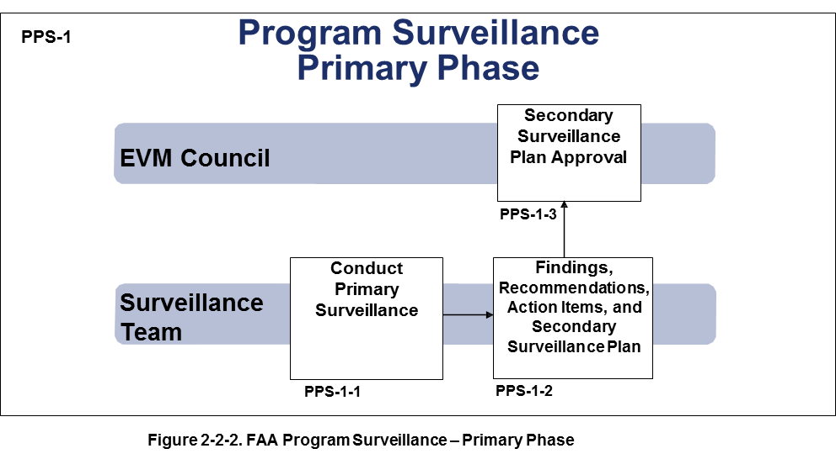

PPS-1 Step | Responsibility | Process Step Description
Conduct Primary Program Performance Surveillance  (PPS-1-1) | EVMFP/Surveillance Team | The EVMFP establishes a surveillance strategy, obtains EVM Council concurrence, and establishes the surveillance team. The Surveillance team, using the program or contractor performance surveillance strategy, prepares the annual surveillance plan.  The contractor surveillance findings and action item report are used to prepare the primary program surveillance plan. This surveillance plan will include the surveillance focus areas, surveillance data sources and schedule.  Implementation Guidance:  - The Surveillance plan will take into consideration prior surveillance reports, and external (IG, GAO, OMB) program performance related reviews and reports.  - In order to minimize the disruption to the programs, the Surveillance Team will obtain as much information from systems, reports, and review charts.  - The surveillance plan includes the process for obtaining program management concurrence for the findings and recommendations. The plan will also include an escalation process, in the event the Surveillance Team and the PM cannot agree on findings and action items.
Findings,  Recommendations,  Action Items, and Secondary Surveillance Plan  (PPS-1-2) | Surveillance Team | The surveillance team prepares a primary program surveillance report. The report summarizes findings, analysis of the findings, and recommendations. The recommendations may be for programs or for functional areas.  The surveillance team prepares the secondary surveillance plan. The secondary surveillance plan includes programs selected for surveillance and areas of focus.  Implementation Guidance:  - Program Offices coordinate lessons learned from the findings and recommendations across all programs.  - The EVM Council members coordinate the selection of programs for secondary surveillance.
Secondary Surveillance Plan Approval  (PPS-1-3) | EVM Council | The EVM Council reviews the primary surveillance report and approves the secondary surveillance plan.  The EVM Council establishes working groups to address primary surveillance recommendations, as necessary

Surveillance - Secondary Phase

Secondary program surveillance is conducted by the surveillance team in coordination with the programs selected for secondary surveillance. The secondary surveillance reviews use additional performance data obtained from the program or contractor such as program schedule, internal program reviews, and control account plans. The secondary phase of program surveillance is illustrated in Figure 2.2.3.

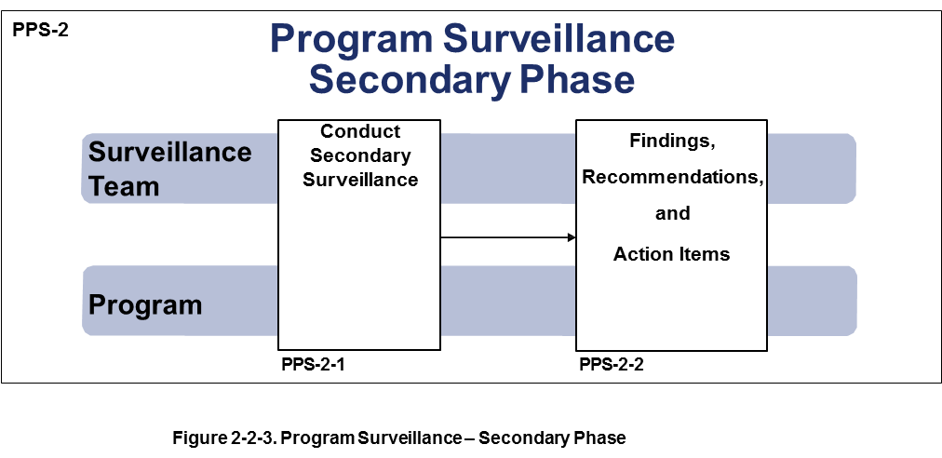

PPS-2 Step | Responsibility | Process Step Description
Conduct Secondary  Surveillance  (PPS-2-1) | Surveillance Team | The surveillance team conducts secondary surveillance with each selected program. The focus of each program surveillance is based on the findings from primary surveillance. EVMFP Office and collateral duty SME FTEs will be included on the surveillance at their request.  Secondary surveillance is based on additional program documentation such as:  - Program schedule  - Program baseline logs  - EVM performance reports  - Contractor program review charts
Conduct Secondary  Surveillance  (PPS-2-1) | Program Manager | The program manager coordinates and provides information to the surveillance team, monitors the surveillance and collaborates with the surveillance team to address findings, recommendations and action items.
Findings,  Recommendations,  and  Action Items  (PPS-2-2) | Surveillance Team | The surveillance team documents and analyzes findings. Recommendations and action items are developed and documented in the surveillance report.  The surveillance team obtains program management concurrence for findings, recommendations, and action items.  Implementation Guidance:  - The recommendations are summarized by Program Office where the program is under EVM surveillance.  - The EVM Council service organization representatives coordinate action item close out
Findings,  Recommendations,  and  Action Items  (PPS-2-2) | Program Manager | Program management coordinates on findings, recommendations, and action items. Program managers are responsible to close out surveillance action items.  Implementation Guidance:  - The service organizations coordinate lessons learned from the findings and recommendations across all programs.

Surveillance Summary Findings and Recommendations

The surveillance team prepares a report summarizing primary and secondary surveillance findings and recommendations. Surveillance findings are summarized and recommendations may include, but are not limited to the following topics:

- Program or contract performance reporting
- Functional area program or contract performance support
- Surveillance procedures and practices

The process for surveillance findings and recommendations is illustrated in Figure 2.2.4.

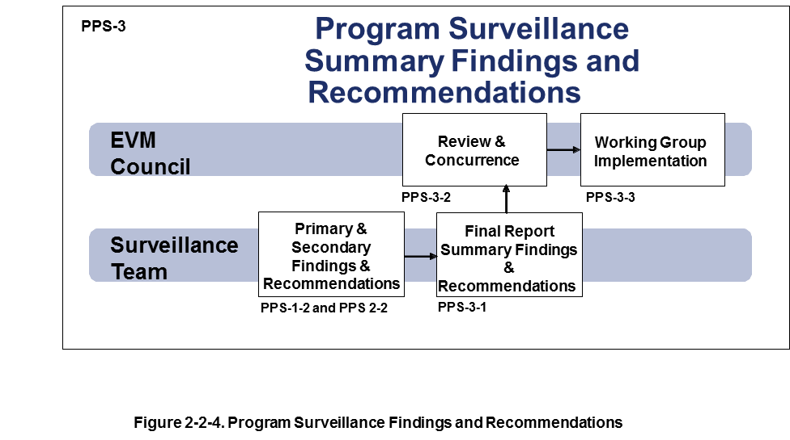
The primary and secondary surveillance findings and recommendations are analyzed and summarized into a final report. The summary report includes the findings and recommendations from primary and secondary surveillance, process steps PPS-1-2 and PPS-2-2. The EVM Council reviews the recommendations and establishes working groups for implementation.

PPS-3 Step | Responsibility | Process Step Description
Summary Findings and Recommendations – Final Report  (PPS-3-1) | Surveillance Team | The surveillance team is responsible for analyzing the findings and recommendations from primary and secondary surveillance. A final report will be prepared which includes recommendations for:  - Portfolio performance management and reporting  - Program performance management and reporting  - Program performance surveillance  - Contractor EVM surveillance  The EVM Council reviews functional (finance, acquisition, systems engineering, etc) related findings, recommendations, and action items. The EVM Council establishes a team to coordinate action item close out with the functional areas.

PPS-3 Step | Responsibility | Description
Review and Concurrence  (PPS-3-2) | EVM Council | The final surveillance report is reviewed by the EVM Council. The findings and recommendations are assessed and concurred by the EVM Council.  The EVM Council coordinates the program performance surveillance reporting with the JRC.
Working Group Implementation  (PPS-3-3) | EVM Council | The recommendations are implemented by establishing EVM Council working groups with service organizations and functional area representatives.  Implementation Guidance:  - The Program Office coordinates lessons learned from the findings and recommendations across all programs.  - Lessons learned from the final report are used to continuously improve program surveillance.

Work Products/Metrics

Surveillance Work Products

Typical work products associated with the Surveillance Process are provided in the table below.

Surveillance Work Products | Description
FAA surveillance strategy | The EVM Focal Point in consultation with the Program Office establishes the surveillance strategy and obtains the EVM Council concurrence. The strategy includes focus areas and programs that are Agency priorities to improve program and contract performance. The strategy includes the plan to establish the surveillance team.
Surveillance plan – primary phase | The primary surveillance plan identifies the schedule, approach and data items used for the high level surveillance.
Surveillance plan – secondary phase | The secondary surveillance plan identifies items, such as findings from the primary surveillance phase, programs selected for secondary surveillance, the surveillance approach, and schedule.
Contractor EVM Surveillance Plan | The FAA program manager’s plan to review contractor EVM compliance consistent with FAA AMS EVM policy.
Contractor EVM surveillance reports | The results of contractor EVM surveillance, as required by AMS policy - EVM Guidance, are provided to the EVM Focal Point and the surveillance team to support the primary surveillance phase.
Documentation Requests | This document lists the type of information and documents that the program being requested to provide the surveillance team. The request includes how the data will be used for surveillance.
Surveillance Findings | The surveillance findings form documents the findings and the impact to program performance reporting. The form includes program management comments on the finding.
Primary Surveillance Findings,  Recommendations,  Action Items Report (includes Secondary Surveillance Plan) | This report summarizes the primary surveillance findings, recommendations, action items, and the plan for secondary surveillance.
Secondary Surveillance Findings,  Recommendations,  Action Items Report | This report summarizes the secondary surveillance findings, recommendations, and action items. This report includes a summary for each program selected for secondary surveillance.
Surveillance Final Report,  Summary Findings and Recommendations – Final Report | The final surveillance report summarizes the results of the primary and secondary reviews. The executive summary provides an overview of key program and systemic findings. Recommendations and corrective actions are provided.  This final report is the basis for the surveillance reports to the JRC, as required.

Surveillance Metrics

Surveillance Metrics | Description
Major Programs Reviewed | The number and % total program value of major programs reviewed during the past 5 years. The goal is to review 100% of FAA major programs every 5 years.
Non-Major Programs Reviewed | The number and % total program value of non-major programs reviewed during the past 5 years. The goal is to review 75 % of FAA non-major program value over a 5 year period.

Glossary of Terms

Term | Definition
Contractor Surveillance | FAA contractor EVMS surveillance is the process of reviewing the health of the earned value management system (EVMS) for one or more FAA programs. The purpose of surveillance is to ensure the continued integrity of contractor EVM Systems consistent with the contract EVMS requirement.
Development / Modernization / Enhancement | The program cost for new investments, changes or modifications to existing systems to improve capability or performance, changes mandated by the Congress or agency leadership, personnel costs for project (investment) management, and direct support. For major IT investments, this amount should equal the sum of amounts reported for planning and acquisition in the OMB Major IT Business Case. (Source: OMB A-11)
Earned Value Management (EVM) | EVM is a methodology that integrates a program’s (or contract’s) work scope, schedule, and resources with risk management, thereby providing government and contractor managers with objective visibility into progress on their programs and the ability to manage effectively. By reliably identifying trends and problems early, EVM helps program managers effectively plan, control, and manage programs so they can take corrective action and re-plan the work, if necessary. Systematic implementation of EVM throughout the organization facilitates comparison of program performance, enabling managers to make better-informed decisions. (Source: FAA EVM Guide)
EVM Council | The Mission of the Earned Value Management Council is to advance the development, evolution, practice, and application of the program management discipline across the FAA. The EVM Council membership includes SMEs with vested interest in integrated program management to include EVM.
EVM Focal Point | The EVM Focal Point has responsibilities for EVMS oversight, contractor EVM certification, and contractor EVM surveillance coordination. FAA EVM Focal Point also establishes agreements with other government agencies to recognize contractor EVM certifications and surveillance reports. EVMFP is responsible for AMS EVM Policy. (Source: FAA EVM Guide)
FAA In-House Surveillance | Reserved
FAA In-House Surveillance | Reserved
EVMS Surveillance | EVM System that is undergoing surveillance (reviews and assessment)
Joint Resources Council (JRC) | The Joint Resources Council is FAA’s corporate-level investment review board. It makes corporate-level resource decisions, including authorization and funding for all investment programs, and approves all changes to the Enterprise Architecture.
Metrics-based Surveillance | Metrics based surveillance is the process of conducting program performance surveillance based on program and contractor performance information used by program management, staff organizations, and executive management.
Primary Surveillance Phase | The primary surveillance phase includes program or contractor performance information and contractor EVMS surveillance reports to determine if there are policy compliance or data integrity issues. The findings from this surveillance phase include recommended candidates for secondary surveillance.
Performance Metrics | Performance related data (e.g., AMS schedule milestones and technical indicators) that are measured over time and provide indications of the technical, schedule, and cost status of a program or contract.
Surveillance | EVMFP in consultation with the Program Office, conducts program-level or contractor surveillance to ensure continued AMS EVM compliance of the approved program or contractor EVM system.
Secondary Surveillance Phase | During the secondary surveillance phase the Surveillance Team utilizes findings from the primary surveillance phase with additional information from the program to determine root causes for policy compliance and data integrity issues discovered during primary surveillance.
Portfolio Program Performance Metrics (P³M) | FAA’s standard program performance metrics used to evaluate program performance that provides an early warning on program performance issues before are realized as problems that can be corrected.
Simplified Program Information Reporting and Evaluation (SPIRE) | SPIRE (Simplified Program Information Reporting & Evaluation) is a web-based application developed to support a variety of FAA financial related functions and reports.

