
Acquisition Management System Guidance

Earned Value Management System Acceptance Guide

April 2017

RECORD OF CHANGES

CHANGE  NUMBER | DATE | NUMBER OF FIGURE, TABLE OR PARAGRAPH | A*  M  D | TITLE OR BRIEF DESCRIPTION | CHANGE  REQUEST  NUMBER
01Update | 3/23/2016 | Entire Document | M | Guide updated to support July 2016 AMS EVMS Policy change | 16-33A
02
03
04
05

*A – ADD, M – MODIFIED, D - DELETED

TABLE OF CONTENTS

1.0 INTRODUCTION 4
1.1. EVM SYSTEM ACCEPTANCE OVERVIEW 4
1.2. BACKGROUND 4
1.3. PURPOSE AND SCOPE 4
2.0 Major programs EVM System Acceptance [RESERVED] 5
3.0 Contractor EVM System acceptance 5
3.1. Contractor EVM System Acceptance Overview 5
3.2. CONTRACTOR EVM SYSTEM ACCEPTANCE PROCESS 6
3.2.1. Contractor EVM System Acceptance – Planning 7
3.2.2. Contractor EVM System Acceptance - Validation Review 11
3.3. Contractor EVM System Acceptance - Formal Recognition 13
3.3.1 Contractor EVM System Acceptance – Advance Agreement 13
3.3.2 Contractor EVM System Acceptance – System Letter of Acceptance 13
aPPENDIX A Glossary of terms 15
aPPENDIX B LIST OF ACRONYMS 16

INTRODUCTION

EVM SYSTEM ACCEPTANCE OVERVIEW

Systems Acceptance is a formal process that involves the reviewing, validating and certifying of the design and implementation of an Earned Value Management System (EVMS) that meets the requirements of the 32 EVMS Guidelines embodied in the Electronic Industry Alliance’s (EIA) -748, Standard for Earned Value Management Systems.

BACKGROUND

The Federal Aviation Administration (FAA) has established requirements for the implementation, use and maintenance of validated earned value management systems on capital asset investments, in order to strengthen performance management and in response to the Government Performance and Results Act (GPRA) and the Office of Management and Budget (OMB) Circular A-11. The requirement for EVM systems that have been validated to meet the EIA-748 Standard – EVMS is addressed in the Acquisition Management System (AMS) and applies to both FAA lines of business, service units and program offices responsible for planning and managing of capital investments, as well as contractors supporting the FAA. The EVM System Acceptance Guide provides guidance and a framework to demonstrate that EVM systems used by FAA programs, organizations and contractors meet the Guidelines for Earned Value Management and will produce program performance data useful for capital investment decision-making.

The EVM Focal Point (AAP-200) is responsible for establishing policy and guidance related to the implementation of EVM as the basis for capital investment program and performance management. The FAA EVM Guide provides general guidance supporting the design and implementation of EVM systems at the FAA and describes the overall process for EVM systems acceptance and surveillance. The EVM System Acceptance Guide, Surveillance Guide and Integrated Baseline Review Guide provide more detailed guidance related to the execution of these specific processes.

PURPOSE AND SCOPE

The intent of this guide is to establish the process and provide guidance for the review, validation and formal acceptance of EVM Systems depended on by the FAA to plan, manage, control, and report performance of capital investment programs. The goal of the EVMS System Acceptance process and the related EVMS Surveillance process is to ensure the integrity of program management systems and the reported performance data used by the FAA and its’ suppliers. This is initially accomplished by:

- verifying and acknowledging program compliance with FAA EVM policies related to the management and performance of capital investments;
- verifying and acknowledging contractor compliance with FAA EVM contractual requirements related to the management and performance of capital investments; and
- verifying program performance data reliability and consistency.

The EVM System Acceptance Guide defines an evaluation and acceptance process for FAA programs and FAA suppliers with an EIA-748 Standard – EVMS requirement to:
- Understand the needs for and effectively design an EVMS.
- Successfully implement the EVMS on the requiring capital investment program.
- Conduct an evaluation of system compliance and its implementation.
- Prepare and provide substantiating documentation for evaluation and implementation.
- Receive approval and documentation that will satisfy the current and future requirements for an approved EVMS.

An overview of the EVM System Acceptance process is depicted in Figure 1-1.

Figure 1.1 EVM Systems Acceptance Process
The EVMS Acceptance Process addresses the need to assess, validate and accept program management systems used by both major FAA programs and contractors. Programs develop the EVMS following the Initial Investment Decision and may undergo an assessment in two phases until the EVMS is determined to meet the requirements. Contractors develop an EVMS and undergo a Validation Review to determine compliance. The EVMS Surveillance process begins once the EVMS has been formally accepted by the FAA and is described in the FAA EVMS Surveillance Guide. In succeeding sections, appropriate guidance will be provided to assist the EVM system owner in fulfilling this responsibility.

Major programs EVM System Acceptance [RESERVED]

Contractor EVM System acceptance

Contractor EVM System Acceptance Overview

The FAA conducts EVMS validation reviews of contractors to verify they have implemented an EVMS as required by the contract and following the guidelines of the EVMS Standard (EIA-748). The AMS FAST includes the EVM contract clauses and Data Item Descriptions under the Procurement Tool Box, and FAA guidance for EIA-748 compliant implementation is in the FAA EVM Guide found in FAST. EVMS validation reviews are conducted by the EVM Focal Point in accordance with this guide and form the basis for formal acceptance of the contractor’s EVMS. The formal acceptance of the contractor’s EVMS is approved by the FAA Acquisition Executive (FAE) and conveyed by the contracting officer via a Letter of EVM Systems Acceptance and/or Advance Agreement, as applicable
This section defines the process for conducting an EVMS validation review and obtaining acceptance by the contracting officer. It also defines the application and use of initial validation reviews, post-acceptance reviews and reviews for cause performed by the EVM Focal Point. The validation review consists of a capability analysis to verify that the proposed EVMS satisfies the guidelines of the EVMS Standard (EIA-748) and a review of the EVMS’ use on programs to verify that it is being used as designed.
Upon completion of the validation review by the EVM Focal Point and correction of non-compliant areas, as required, the FAE approves acceptance of the proposed EVMS and directs the preparation of an Advance Agreement. The contracting officer issues a Letter of System Acceptance stating that the contractor’s EVMS meets the guidelines of EVMS Standard (EIA-748). FAA also recognizes contractor EVM Systems that have been reviewed and accepted by Defense Contract Management Agency (DCMA). The FAA also develops memorandums of understanding (MOU) for acceptance of contractor EVM Systems that have been reviewed by other civilian agencies (January 2016 Reciprocity MOU).
When a contractor has a contract with the FAA and employs an EVMS that has been formally accepted by the FAA, DCMA, or other civilian agencies as compliant with FAA’s implementation of the EVMS Standard (EIA-748), the Contracting Officer may recognize the system as being acceptable for other programs. FAA’s acceptance of the system for other programs depends on the outcome of the EVMS surveillance process. Because management systems are dynamic due to personnel and other changes, surveillance plays a key role in ensuring the continued integrity of the system. Without an effective surveillance plan and process, the FAA may not unconditionally accept the EVM system. The EVM Focal Point and the program manager jointly verify and demonstrate to the FAE and the contracting officer that the system is being used properly and effectively.

CONTRACTOR EVM SYSTEM ACCEPTANCE PROCESS
The objective of the contractor EVM System Acceptance process is for the supplier to demonstrate that its EVM System follows the guidelines of the EIA-748 Standard – EVMS, as required by the contract. Key elements of the contractor EVM System Acceptance process include the following:
- An EVM Systems Implementation Plan is prepared by the contractor and reviewed by the FAA.
- The contractor EVMS is designed and implemented.
- The Validation Review Plan is prepared by the FAA and provided to the contractor.
- An EVMS Progress Assistance Visit may be conducted (Optional).
- The Validation Review is conducted; the Validation Review Report is prepared.
- Corrective actions are identified, addressed and resolved.
- The contractor EVMS is accepted and the Letter of Systems Acceptance or Advance Agreement is issued to the contractor. Usually, Agencies require an acceptable surveillance plan and system change management plan from the supplier to obtain an Advance Agreement.
- EVMS surveillance commences.

The key event in the Systems Acceptance process is the EVMS Validation Review. The Validation Review is coordinated between the contracting officer and the supplier to provide the means to assess the contractor’s EVMS and to verify:

- The system, as described, meets the intent of the 32 Guidelines as described by the EVMS Standard (EIA-748) and the NDIA EVMS Intent Guide.
- The system, as described, is fully implemented on the selected programs.
- The implementation is successful and complies with the requirements of the system description/contractor’s EVMS policy and procedures and (if appropriate) program unique procedures.
- The system implemented provides timely, accurate, and auditable management information for both the contractor’s project management and the FAA.

The EVMS Validation Review results are documented by the Validation Review Team to provide a written record of the review and the contractor’s responses (if available) to the FAA Acquisition Executive. The Acquisition Executive determines with the support of the FAA EVM Focal Point, if the review results warrant acceptance of the contractor’ EVMS and the provision of an Advance Agreement to the supplier.

The contractor EVM System Acceptance process is described in greater detail in the sections below.

Contractor EVM System Acceptance – Planning
Planning for the formal acceptance of the contractor’s EVMS is critical to proposing and implementing an EVMS that is acceptable to the FAA. The planning for EVMS System Acceptance begins with the establishment of the requirement for the contractor to propose and provide an EVMS that follows the guidelines of the EVMS Standard (EIA-748). The contractual requirement may include EVMS compliance with validation or compliance only.
In the case of EVMS compliance with validation, the contractor that proposes to use an EVMS previously accepted by the Government may satisfy this requirement by citing and providing a copy of the current Advance Agreement and providing a copy of the approved system description. The FAA EVM Focal Point in consultation with the Contracting Officer will review the basis of the prior EVMS system acceptance and make a recommendation to the FAA Acquisition Executive, as to whether the FAA should accept the proposed EVMS and issue an FAA Advance Agreement or Letter of Systems Acceptance. Factors to be considered by the FAA in reviewing the prior systems acceptance include:
- Current Memorandum of Agreement between the FAA and the responsible federal agency that issued the Advance Agreement.
- If no Memorandum of Agreement exists, then the basis of the EVM System Acceptance (Advance Agreement) and the source of the supporting Validation Review.
- Currency of the EVM System Acceptance and the supporting Validation Review.
- Applicability of the EVM System Acceptance to the relevant contractor organization and/or location.
- Current and ongoing EVMS surveillance, as demonstrated by current surveillance plans, surveillance reports and records of approved system changes.
In the case of EVMS compliance with validation, the contractor that does not have a previously accepted system should submit an EVMS Implementation Plan, as required by the contract, to obtain the EVM system acceptance.
In the case of EVMS compliance only, if the contractor proposes to use an EVMS that has not been formally accepted, the proposal should include a written summary of the EVMS. The description of the contractor's EVMS must be in sufficient detail to show how it complies with the EVMS Standard EIA-748 and address all guidelines. The FAA recognizes the completion and submission of the Compliance Map Templates included in Appendix A of the NDIA EVM Intent Guide, as a best practice to demonstrate how the proposed EVMS complies with the contractor’s implementation of the EVMS Standard (EIA-748). A contractor may elect to keep the system description general and rely on cross-referencing to internal procedures or policy manuals for a discussion of the details. In this case, the procedures and policy documents are to be referenced in, and considered a part of, the EVMS summary description.

In the case of EVMS compliance only, the contractor may elect to propose and use a previously accepted EVMS to meet this requirement and can satisfy this requirement by citing the Advance Agreement or Systems Letter of Acceptance, and providing a copy of the approved system description.

Figure 3-2-1 provides an overview of the Contractor Systems Acceptance planning process, assuming that compliance with validation is required and the contractor has not proposed to use an EVMS, previously accepted by a Government Agency. It may also apply to any contract that requires compliance without a requirement for systems acceptance or validation, wherein both the Government and the contractor agree it is in their best interests to achieve a formal acceptance of the contractor’s EVMS.

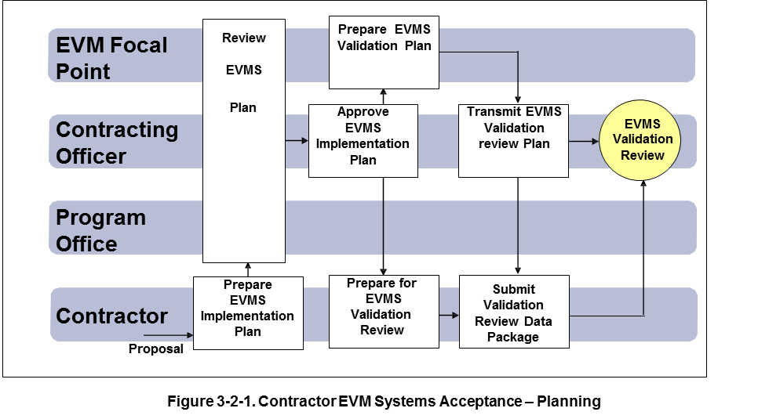

The contractor prepares the EVMS Implementation Plan and submits the Plan as part of the proposal in response to the Screening Information Request. The Plan should:

- describe the EVMS the contractor intends to use in performance of the contract, and how the proposed EVMS complies with the EVMS guidelines in EIA-748.
- distinguish between the contractor's existing management system and modifications proposed to meet the EVMS guidelines.
- describe the management system and its application in terms of the EVMS guidelines.
- describe the proposed procedure for administration of the EVMS guidelines as applied to subcontractors.
- describe the process the contractor will use to determine subcontractor compliance with the EVMS Standard (EIA-748).
- the contractor must provide information and assistance as required by the Contracting Officer to support review of the plan.
- the contractor’s EVMS plan must provide milestones that indicate when the contractor anticipates that the EVMS will be compliant with the guidelines in EIA-748.
- the contractor must identify the subcontractors, or major subcontracted effort if subcontractors have not been selected, to whom the EVMS requirements will apply.
- a schedule that provides a timetable of events leading up to Government validation of the contractor’s EVMS. This schedule should include a Progress Assistance Visit (PAV), if requested. The formal EVMS Validation Review is conducted as soon as practicable.

The contractor’s EVMS Implementation Plan is reviewed by the Contracting Officer, the proposal evaluation team and the EVM Focal Point. The FAA will approve the plan before contract award and monitor the contractor’s progress towards achieving formal acceptance of the EVMS.

The EVM Focal Point prepares an EVMS Validation Review Plan. The following description of the Validation Review planning includes reference to the exhibits used during the EVMS Validation Review. The review plan and the content of the exhibits may be modified based on the review scope and the understanding of the program(s) or contract(s) being used for the validation review. The exhibits used for the contractor EVMS validation reviews are maintained by and available from the EVM Focal Point. The contractor EVMS validation exhibits are:

Exhibit A – EVMS Implementation Plan
Exhibit B - EVMS Validation Review Team Assignments
Exhibit C - EVMS Validation Review Documentation Request
Exhibit C1 - EVMS Documentation Review Instructions
Exhibit D - EVMS Validation Review Agenda
Exhibit E - EVMS Validation Review - Corrective Action Request (CAR)
Exhibit F - EVMS Validation Review - Certification Report Outline
Exhibit F1 - EVMS Validation Review - Sub-Team Report of Findings
Exhibit F2 - EVMS Validation Review - Continuous Improvement Opportunity
Exhibit F3 - EVMS Validation Review - Corrective Action Request Log
Exhibit F4 - EVMS Validation Review - Continuous Improvement Opportunity Log
Exhibit G - EVMS Validation Review - In-briefing Outline
Exhibit H - EVMS Validation Review - Out-briefing Outline
Exhibit I - Reserved
Exhibit J – Reserved
Exhibit K1 - EVMS Validation Review - Executive Interview Guide
Exhibit K2 - EVMS Validation Review - Control Account Manager Interview Guide
Exhibit K3 - EVMS Validation Review – Business Manager Interview Guide
Exhibit K4 - EVMS Validation Review – Schedule Analyst Interview Guide

Validation Review planning should result in a definition for the following:

  - Validation Review Scope
The scope of the review will depend on the number and size of contracts included in the review. Other considerations include the number of control accounts, the number of subcontractors with performance reporting requirements, and contractual reporting requirements. The supplier may have previously completed Government audits or financial reviews that may serve to satisfy some of the EVMS Standard (EIA-748) Guidelines, such as, accounting and indirect cost guidelines. The Validation Review Plan will include copies of Government audits and system acceptances provided by the supplier. FAA will approve the request to use existing certifications to satisfy compliance with EVMS Standard (EIA-748). The program(s) or contract(s) included in the Validation Review is documented in Validation Review Plan, (see Exhibit A).
  - Validation Review Schedule
The agenda and schedule for the assessment is related to the review scope. Usually Validation Reviews are at least one week and seldom exceed two weeks. An example of a five day review is provided in Exhibit D, EVMS Validation Review Agenda and an outline of the in-briefing charts are provided in Exhibit G, In-briefing Outline.
  - Resource plan
The resource plan is related to the review scope, review plan, and schedule. The review team will include a Team Lead and analysts that can conduct the assessment and prepare the Validation Review Report. The team members should be familiar with the EVMS Standard (EIA-748), review methodology, and the products being reviewed. Training may be required for team members. The Validation Review team assignments are documented in Exhibit B, Review Team Assignments.
  - Progress Assistance Visit
In some circumstances, it may be advisable for the supplier to have the FAA conduct a Progress Assistance Visit to determine the readiness of the supplier for the formal Validation Review. The Progress Assistance Visit is an initial assessment of the contractor’s readiness to demonstrate its EVMS compliance. The visit is conducted prior to the Validation Review, identifies the supplier weaknesses and strengths, and usually combines a documentation review with an on-site 1 – 2 day review. Recommendations are provided to the supplier to assist with their preparation for the Validation Review.
The review is conducted by the FAA within 90 days or as mutually agreed to by the FAA and the contractor. Representatives of the review team should visit the contractor's facility and review the contractor's plans for implementing a guideline-compliant EVMS. The visit includes an initial review of the system description. Areas of noncompliance and potential problems are identified. This visit provides an early dialogue between the review team and the contractor on the validation review process. During this preliminary visit the contractor usually makes presentations on the system’s design and operation and explains applicable reports. The team should examine selected documents and procedures proposed by the contractor and a schedule should be developed to accomplish the Validation Review in accordance with the EVMS Implementation Plan submitted by the contractor.
  - Pre-Validation Documentation Review Plan
Prior to the Validation Review, documentation is reviewed by the assessment team to allow them to become familiar with the supplier EVMS and the program or contract that will be reviewed. An example of the documentation request is provided in Exhibit C, Documentation Request.
  - Validation Review Interview Guides
After preparation of the Validation Review Plan and documentation, the interview guides should be reviewed to ensure that questions and areas are adequate and applicable. The templates for the interview guides are provided in Exhibits K, Validation Review Interview Guides.
- Validation Review Template
Prior to the Validation Review, the Validation Review Template is reviewed and updated to reflect the review strategy based on the review planning activities. The templates include a section for review strategy and documentation strategy; see Exhibit L, EVMS Validation Review Template. The templates include the EVMS Standard (EIA-748) guidelines and the NDIA Intent Guide.
The EVMS Validation Review Plan, once prepared and approved, is forwarded to the contractor to assist with their planning for the Validation Review. The following criteria should be met prior to conducting the EVMS Validation Review:
- The contractor has a contractual requirement to implement an EVMS that follows the guidelines of the EVMS Standard (EIA-748).
- The EVMS Implementation Plan, including subcontractors is approved by the EVM Focal Point and the contracting officer.
- The supplier has designed and implemented an EVMS and has managed the program using earned value management (on at least one program or contract) for at least two reporting periods.
- Suppliers with major subcontractor EVM, schedule, or performance reporting requirements have major subcontractor systems approved by the supplier. The major subcontractors will have submitted at least one performance report(s).

Contractor EVM System Acceptance - Validation Review
The purpose of the Validation Review is to conduct a formal assessment of the contractor’s proposed EVMS compliance with the EVMS Standard (EIA-748). Successful demonstration of the EVMS and completion of the review results in the validation of the contractor’s EVMS. The primary objectives of the Validation Review are to:

- Evaluate management system capabilities against the EVMS Standard (EIA-748).
- Assess the description of the management system to determine if it adequately describes the management processes demonstrated during the review, and
- Evaluate the application of the management system on the contract being reviewed.
Figure 3-2-2 provides an overview of the Contractor EVMS Validation Review process, and the issuance of the system acceptance.
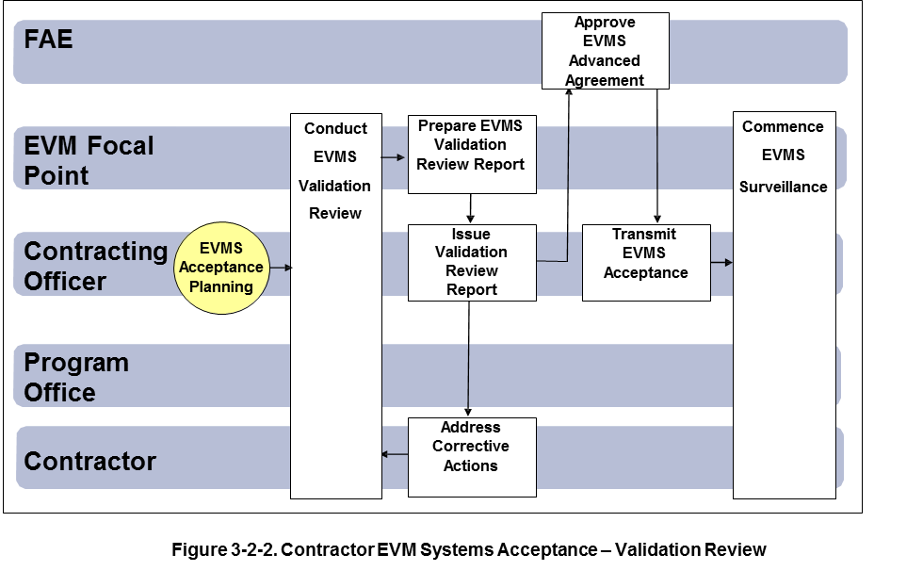
The Validation Review begins no later than 90 days after the implementation of the EVMS. The review consists of system documentation reviews, data traces, and interviews with contractor personnel. The contractor’s EVMS is assessed against each guideline contained in EIA-748. The review should be organized to follow the system approach taken by the contractor, i.e., orientation by EIA-748 grouping or a process approach.
The contractor should have a current, approved written system description available. Applicable procedures also need to be available at the contractor’s operating levels as necessary to demonstrate a consistent approach. The review team examines the contractor’s working papers and documents to ascertain compliance and to document its findings. The contractor should make documents used in the contractor’s EVMS available to the team. The documentation needs to be current and accurate. The contractor demonstrates to the team how the EVMS is structured and used in actual operation. The Validation Review includes, but is not limited to, the following activities:
- An overview briefing by the contractor to familiarize the review team with the proposed EVMS. The overview should identify any changes which have occurred since the most recent Progress Assistance Visit, if applicable.
- A review, of the documentation that establishes and records changes to the baseline plan for the contract. This includes work authorizations, schedules, budgets, resource plans, and change records including management reserve and undistributed budget records. The purpose is to verify that the contractor has established and is maintaining a valid, comprehensive integrated baseline plan for the contract.
- A review, on a sample basis, of the reporting of cost and schedule performance against the baseline plan, along with appropriate analyses of problems and projection of future costs. Also, a trace is conducted to summarize the cost/schedule performance data from the lowest level of formal reporting (normally the control account level) to the external performance measurement report. The purpose of this activity is to verify the adequacy of the control aspects of the system and the accuracy of the resulting management information.
- Interviews with a selected sample of Control Account Managers (CAM)s, functional and other work teams, and PMs to verify that the contractor's EVMS is fully implemented and being used in the management of the contract.
- An exit briefing covering the team's findings. During this briefing, any open system discrepancies should be discussed along with the contractor's corrective action plan, which establishes responsibility and a time-frame for corrective action.

Figure 3-2-3 provides an overview of the specific activities conducted during the Contractor EVMS Validation Review.

Figure 3-2-3. Contractor Validation Review

After the exit criteria for the Validation Review has been met, the on-site Validation Review usually concludes with the out-briefing conducted by the review Team Lead. The purpose of the out-briefing is to summarize major findings, strengths, weaknesses, and potential process improvements. The out-briefing includes the plan to close open Corrective Action Requests (CARs). An outline of the out-briefing charts is provided in Exhibit H, Out-briefing Outline.
At the conclusion of the Validation Review, the Team Lead is responsible for a written report within 30 working days after the completion of the review. The written report must be amended to reflect progress against the contractor’s corrective action plan to resolve material discrepancies identified during the Validation Review.
As a minimum, the following is required prior to completing the final Validation Review Report:
  - All Major Corrective Action Requests (CARs), see Exhibit E, are completed and accepted by the Validation Review team.
  - All minor CAR action plans are approved by the Validation Review team.
  - The final EVMS Validation Review Report is signed by the review team lead and the EVM Focal Point.
Exhibit F provides the Validation Review Report outline. The Validation Review Report is supported with sub-team report of findings consistent with the review team assignments. Exhibit F-1, Sub-Team Report of Findings, provides the form to document the review team findings. The supplier will be provided with a description of the potential process improvements identified by the Validation Review team. Exhibit F-2, Continuous Improvement Opportunities (CIO), is the form used to describe the potential process improvements. The Validation Review Report will include a log and disposition of CARs and CIOs which are provided in Exhibit F-3, CAR Log, and Exhibit F-4, CIO Log.
Occasionally major CARs remain open beyond the review and should be closed within a short period of time, usually 30 to 45 days. Major CARs that are not closed out within a reasonable amount of time may require an additional on-site review to close out the CAR. After all major corrective actions have been addressed and approved by the review team lead; the report is amended to reflect progress against the contractor’s corrective action plan to resolve material discrepancies. Minor CAR status is reported to the FAA EVM Focal Point on a regular basis, i.e., monthly, until all CARs are closed. Contractual actions may be initiated when Validation Review results dictate.

Contractor EVM System Acceptance - Formal Recognition
Contractor EVM system acceptance is formally granted to the contractor through the issuance of either an Advance Agreement or a System Letter of Acceptance. The Advance Agreement between the FAA, and contractor represents a binding agreement that the contractor maintain and use the accepted EVMS as an integral management process on current, as well as future contracts with the FAA. The Advance Agreement also documents the Government’s intent to minimize system reviews and the contractor's corporate commitment to continue to use and maintain the EVMS consistent with the guidelines for current and future Government contracts through an internal surveillance program. The System Letter of Acceptance represents an acknowledgement by the FAA that the contractor has satisfied an individual contractual requirement to implement and use a program management system that follows the guidelines established by the EVMS Standard (/EIA-748).

Contractor EVM System Acceptance – Advance Agreement

An EVM System Acceptance Advance Agreement between a supplier and the FAA represents a binding agreement to:
- Maintain the corporate or business unit EIA-748 compliant EVMS system and procedures as approved by the FAA. The business units and/or locations subject to the EVMS Advance Agreement are identified.
- Continuously improve the EVMS systems and obtain FAA EVM Focal Point approval for system changes. The Advance Agreement will define the process and of type of changes requiring the FAA EVM Focal Point approval.
- Participate in EVM surveillance with the FAA to ensure the supplier EVMS system is providing reliable, timely and actionable program performance data.
- FAA acceptance of the supplier EVMS system for future contracts requiring EVMS, contingent with the supplier compliance with the EVM System Acceptance Advance Agreement.
The Advance Agreement may be executed following the successful completion of an EVMS Validation Review, the recommendation of the EVM Focal Point and the approval of the FAA Acquisition Executive. Once executed, the Advance Agreement remains in effect indefinitely and should be referenced and incorporated into each future contract requiring a validated EVM system. The Advance Agreement is signed by the responsible Contracting Officer and a contractor representative at the commensurate level. For example, if the validation is for an EVMS used throughout a corporation’s division, the appropriate contractor representative may be the division manager. FAA Program Managers should be aware of the existence of Advance Agreements with their contractors in order to take maximum advantage of the agreements contained therein in establishing compliance with each individual contract requirement. The use of the Advance Agreement over the System Letter of Acceptance option should be considered whenever possible, as the Advance Agreement documents and codifies the contractor’s commitment to maintain, apply and use the EVMS on future contracts and on a corporate basis.

Contractor EVM System Acceptance – System Letter of Acceptance

A Contractor EVM System Acceptance – System Letter of Acceptance is binding agreement to:
- Maintain the EIA-748 compliant EVMS system and procedures as approved by the FAA. The business units and/or locations subject to the EVMS Letter of Acceptance are identified.
- Continuously improve the EVMS systems and obtain FAA EVM Focal Point approval for system changes. The Letter of Acceptance will define the process and of type of changes requiring the FAA EVM Focal Point approval.
- Participate in EVM surveillance with the FAA to ensure the supplier EVMS system is providing reliable, timely and actionable program performance data.
A System Letter of Acceptance is an alternative method to convey EVM system acceptance following a successful Validation Review. The System Letter of Acceptance documents the validation of the EVM system for use within the contractor’s facility, and for the instant contract that established the requirement. The System Letter of Acceptance does not extend acceptance to a corporate level, nor does it convey acceptance to future contracts. In some cases, a company may only wish to agree to a facility wide commitment to EVM. The System Letter of Acceptance may be executed following the successful completion of an EVMS Validation Review, the recommendation of the EVM Focal Point and the approval of the Contracting Officer. The System Letter of Acceptance remains in effect for the duration of the contract and should be referenced or incorporated into each successive contract modification at the facility requiring a validated EVM system.

aPPENDIX A
Glossary of terms

Accepted EVMS System | An EVM system that has been formally accepted by an organization, customer or third party representing the customer as compliant with the EIA-748 Standard – EVMS. The acceptance of the EVMS is documented by an EVMS Advance Agreement (AA) or an EVM System Letter of Acceptance (LOA)
Validated EVMS System | An EVM System that has been formally reviewed and determined to be compliant with the intent of the EIA-748 Standard – EVMS and consistent with the NDIA EVMS Intent Guide. EIA-748 compliance is determined by an independent qualified review team.
EVMS Validation Review | A formal process to assess an EVMS and determine EVM System Owner’s compliance with the EIA-748 Standard – EVMS. The review determines if the intent of the 32 EVMS Guidelines is embodied in the integrated processes and sub-processes of an organization’s methods of operation that generates reliable, timely, and actionable program/contract performance data.
EVMS Compliance | EIA-748 Standard – EVMS compliance as required by FAA policy for programs and suppliers.
Earned Value Management System (EVMS) | The integrated set of policies, processes, procedures, systems, and practices that meet the intent of the guidelines in American National Standard EIA-748, Earned Value Management Systems.
EVMS Guidelines | The 32 EVMS guidelines contained in American National Standards Institute/Electronics Industries Alliance EIA-748 - Current Version, Earned Value Management Systems.
EVM System Owner | The FAA program or supplier responsible for the implementation and use of an Earned Value Management System compliant with the EIA-748 – EVMS Guidelines.

aPPENDIX B
LIST OF ACRONYMS

AA | Advance Agreement
AMS | Acquisition Management System
CAM | Control Account Manager
CAR | Corrective Action Request
CIO | Continuous Improvement Opportunities
DCMA | Defense Contract Management Agency
EIA | Electronics Industries Alliance
EVM | Earned Value Management
EVMS | Earned Value Management System
FAA | Federal Aviation Administration
FID | Final Investment Decision
GAO | General Accounting Office
GPRA  IPMD | Government Performance and Results Act  Integrated Program Management Division
JRC | Joint Resources Council
NDIA | National Defense Industrial Association
OMB | Office of Management and Budget
PAV | Progress Assessment Visit
PF | Post FID
WBS | Work Breakdown Structure

